
LegalXML Electronic Court Filing 4.0
Working Draft, March 17, 2008
Document Identifier:
0000.doc
OASIS Identifier:
[OASIS document number]
Location:
Persistent: http://docs.oasis-open.org/legalxml-courtfiling/specs/ecf/v4.0/ecf-v4.0-spec-cd01.zip
This Version: http://docs.oasis-open.org/legalxml-courtfiling/specs/ecf/v4.0/ecf-v4.0-spec-cd01.zip
Previous Version: http://docs.oasis-open.org/legalxml-courtfiling/specs/ecf/v3.1/ecf-v3.1-spec-01.zip
Technical Committee:
OASIS LegalXML Electronic Court Filing TC
Chairs:
John Greacen, Greacen Associates
Ron Bowmaster, Utah Administrative Office of the Courts
Editor:
Roger Winters, Administrative Office of the Courts of Washington and King County Department of Judicial Administration
Contributors:
James Cabral, MTG Management Consultants
Subject/Keywords:
Legal, Government, Court, E-Filing
OASIS Conceptual Model topic area:
Specialized Process
Related work:
This specification replaces or supersedes:
- LegalXML Electronic Court Filing 3.0, 3.01 and 3.1
This specification is related to:
- National Information Exchange Model 2.0
Abstract:
This document defines the LegalXML Electronic Court Filing 4.0 (ECF 4.0) specification, which consists of a set of non-proprietary XML and Web services specifications, along with clarifying explanations and amendments to those specifications, that have been added for the purpose of promoting interoperability among electronic court filing vendors and systems. ECF Version 4.0 is a major release and brings the specification into conformance with the National Information Exchange Model (NIEM) 2.0.
Status:
This document is a Working Group Draft NOT yet accepted by the Working Group as a consensus, rather it will serve as the basis for discussions. As a work in progress, this document should NOT be considered authoritative or final and will be superseded by future versions.
Technical Committee members should send their comments regarding this specification to the workgroup_mailer@lists.oasis-open.org list. Others should subscribe to, and send comments to, the mailto:legalxml-courtfiling@lists.oasis-open.org list. To subscribe, send an email message to mailto:legalxml-courtfiling@lists.oasis-open.org?subject=Subscribe with the word “subscribe” as the body of the message.
Notices
OASIS takes no position regarding the validity or scope of any intellectual property or other rights that might be claimed to pertain to the implementation or use of the technology described in this document or the extent to which any license under such rights might or might not be available; neither does it represent that it has made any effort to identify any such rights. Information on OASIS’s procedures with respect to rights in OASIS specifications can be found at the OASIS Website. Copies of claims of rights made available for publication and any assurances of licenses to be made available, or the result of an attempt made to obtain a general license or permission for the use of such proprietary rights by implementors or users of this specification, can be obtained from the OASIS President.
OASIS invites any interested party to bring to its attention any copyrights, patents or patent applications, or other proprietary rights which may cover technology that may be required to implement this specification. Please address the information to the OASIS President.
Copyright © OASIS Open 2007. All Rights Reserved.
This document and translations of it may be copied and furnished to others, and derivative works that comment on or otherwise explain it or assist in its implementation may be prepared, copied, published and distributed, in whole or in part, without restriction of any kind, provided that the above copyright notice and this paragraph are included on all such copies and derivative works. However, this document itself does not be modified in any way, such as by removing the copyright notice or references to OASIS, except as needed for the purpose of developing OASIS specifications, in which case the procedures for copyrights defined in the OASIS Intellectual Property Rights document must be followed, or as required to translate it into languages other than English.
The limited permissions granted above are perpetual and will not be revoked by OASIS or its successors or assigns.
This document and the information contained herein is provided on an “AS IS” basis and OASIS DISCLAIMS ALL WARRANTIES, EXPRESS OR IMPLIED, INCLUDING BUT NOT LIMITED TO ANY WARRANTY THAT THE USE OF THE INFORMATION HEREIN WILL NOT INFRINGE ANY RIGHTS OR ANY IMPLIED WARRANTIES OF MERCHANTABILITY OR FITNESS FOR A PARTICULAR PURPOSE.
Table of Contents
1 Introduction 6
1.1 Scope 6
1.2 Relationship to Prior Specifications 7
1.3 Relationship to other XML Specifications 7
1.3.1 National Information Exchange Model (NIEM) 8
1.3.2 OASIS Universal Business Language 8
1.3.3 W3C XML-Signature Syntax and Processing 8
1.3.4 OASIS Reference Model for Service Oriented Architecture 9
1.4 Terms and Definitions 9
1.5 Symbols and Abbreviations 10
1.6 Normative References 10
1.7 Non-Normative References 11
2 ECF 4.0 Architecture 12
2.1 Core vs. Profiles 12
2.2 Major Design Elements 12
2.3 Information Model 13
2.3.1 Messages 13
2.3.2 Attachment 14
2.3.3 Sample Message Streams 14
2.4 Court Policy 17
2.4.1 Human-Readable Court Policy 18
2.4.2 Machine-Readable Court Policy 18
2.4.3 Court Extensions 18
2.4.4 Court-Specific Code Lists 19
2.4.5 Court-Specific Constraint Schemas 20
3 ECF 4.0 Process Model 21
3.1 The Filing-Preparation-to-Docketing Process Model 21
3.2 Business Rules 23
3.2.1 GetPolicy 23
3.2.2 GetServiceInformation 23
3.2.3 GetFeesCalculation 23
3.2.4 ReviewFiling 23
3.2.5 ServeFiling 23
3.2.6 RecordFiling 24
3.2.7 NotifyDocketingComplete 24
3.2.8 NotifyFilingReviewComplete 24
3.2.9 GetFilingList 24
3.2.10 GetFilingStatus 24
3.2.11 GetCaseList 24
3.2.12 GetCase 25
3.2.13 GetDocument 25
3.3 Message Business Rules 25
3.3.1 Identifiers 25
3.3.2 Code Lists 26
3.3.3 Message-Specific Business Rules 27
4 ECF 4.0 Schema 28
4.1 ECF 4.0 Message Schemas 28
4.2 ECF 4.0 Case Type Schemas 29
4.3 ECF 4.0 Code List Schemas 30
5 Service Interaction Profiles 32
5.1 Service Interaction Profile Requirements 32
5.2 Service Interaction Profile Approval and Revision Processes 33
5.3 Supported Service Interaction Profiles 33
6 Document Signature Profiles 35
6.1 Document Signature Profile Requirements 35
6.2 Document Signature Profile Approval and Revision Processes 35
6.3 Supported Document Signature Profiles 36
Appendix A. (Informative) Release Notes 37
A.1 Availability 37
A.2 Package Structure 37
A.3 Recursive Structures 37
A.4 Date and Time Formats 37
A.5 Known Errata 37
Appendix B. (Informative) ECF 3.0 Development Approach and Artifacts 39
B.1 Principles 39
B.2 Approach 39
B.3 ECF 4.0 Exchange Content Models 39
B.4 Spreadsheet Models 41
Appendix C. (Informative) MDE Operations 42
C.1 Filing Assembly MDE 42
C.1.1 Provided Operations 42
C.1.2 Consumed Operations 42
C.2 Filing Review MDE 43
C.2.1 Provided Operations 43
C.2.2 Consumed Operations 44
C.3 Court Record MDE 44
C.3.1 Provided Operations 44
C.3.2 Consumed Operations 45
C.4 Legal Service MDE 45
C.4.1 Provided Operations 45
C.4.2 Consumed Operations 45
Appendix D. (Informative) Example Instances 46
Appendix E. (Informative) Ongoing Work Items 48
Appendix F. (Informative) Acknowledgments 49
Appendix G. (Informative) Revision History 50

Introduction
This document is a specification developed by the OASIS LegalXML Electronic Court Filing Technical Committee. It defines a technical architecture and a set of components, operations and message structures for an electronic court filing system, and sets forth rules governing its implementation.

Scope
This specification describes the technical architecture and the functional features needed to accomplish a successful electronic court filing system, and defines both the normative (required) and non-normative (optional) business processes it supports. The non-functional requirements associated with electronic filing transactions, as well as the actions and services needed to accomplish the transactions, such as network and security infrastructures, are defined in related specifications, namely:
- Service interaction profile specifications that define communications infrastructures, within which electronic filing transactions can take place
- Document signature profile specifications that define mechanisms for stating or ensuring that a person signed a particular document

This specification supports the following automated information exchanges:
- Transmission of documents in electronic form from law firms and from other persons and organizations to a court for entry (“official filing”) into the court’s official case records
- Recording of documents in electronic form from members of the court and court administrators into the court’s official case records
- Transmission of data needed to complete (or demonstrate the previous completion of) financial transactions involving filing fees or the payment of any other court fees, fines and financial obligations
- Transmission of the metadata needed to initiate a new case record in a court’s automated case management system (CMS) when the document being transmitted is one that commences a new case in that court
- Transmission of the metadata needed to create an entry that records (indexes) a filed document in a court’s electronic listing of cases and their contents (variously called a “docket” or “register of actions”)
- Transmission of the metadata needed to update the information recorded about a case that is maintained in a court’s CMS
- Messages returned to the sender that confirm a court’s receipt of the sender’s filing message
- Messages notifying the sender of events such as the entry of the document(s) submitted by the sender into the court record (or an error message stating that the document[s] could not be accepted for filing and stating the reason[s] why)
- Queries to the court seeking information about data and documents held within the court’s official electronic records and the return of information in response to those queries
- Queries from filers for the court rules and requirements for electronic filing
- Queries by filers seeking from the court record system the names and addresses of parties in a case who must be served and whether by traditional or electronic means
- Transmission of copies of documents submitted for filing to the other parties in a case who are registered to receive service electronically

In addition to filing of court case documents, this specification supports “secondary service” – the delivery of copies of filed documents to persons who have already been made parties to a case. This specification does NOT support “primary service,” which entails the service of summonses, subpoenas, warrants and other documents that establish court jurisdiction over persons, making them parties to a case. Therefore, this specification does NOT support the following automated information exchanges:
- A query by a filer seeking from the court record system the names and addresses of parties in a new case who must be served to establish court jurisdiction over them in the new case
- Transmission of copies of or links to documents submitted for filing to any party in a new case or any newly added parties in an existing case

This specification defines a set of core structures that are common to most types of court filings and defines specific structures that apply to filing documents in the following types of court cases:
- Appellate
- Bankruptcy
- Civil (including general civil, mental health, probate and small claims)
- Criminal (both felony and misdemeanor)
- Domestic relations (including divorce, separation, child custody and child support, domestic violence and parentage, i.e., maternity or paternity)
- Juvenile (both delinquency and dependency)
- Violations (including traffic, ordinances and parking)

Although ECF 4.0 does not define data structure elements specific to other case types (e.g., administrative tribunals), the basic structure will support other types of court filings and is extensible through court-specific and case-type-specific extensions.

Relationship to Prior Specifications
Electronic Court Filing 4.0 supersedes the LegalXML Electronic Court Filing 3.0, 3.01 and 3.1 specifications developed by the predecessor organizations to the OASIS Electronic Court Filing Technical Committee. Those specifications were prepared for and approved by the COSCA/NACM Joint Technology Committee as proposed standards.
Relative to the previous specifications, this specification provides a number of enhancements including:
- The use of XML Schema rather than Document Type Definitions (DTDs)
- Leveraging of the National Information Exchange Model ([NIEM]), a national standard for information sharing
- Leveraging of the updates to the OASIS Universal Business Language ([UBL]), for describing payments
- The inclusion of the data elements needed for appellate cases

This specification does not assume that prior specifications will be deprecated. However, ECF 4.0 is not backward-compatible and applications using the prior specifications will not interoperate successfully with applications using these specifications. This fact is indicated by the assignment of a new major version number to this specification.

Relationship to other XML Specifications
The ECF specification incorporates other existing, non-proprietary XML specifications wherever possible. In particular, the specification has dependencies on the [NIEM], the [UBL] data library and the World Wide Web Consortium (W3C) XML Digital Signatures specification. The terminology used in this specification to describe the components of the ECF technical architecture conforms with the OASIS Reference Model for Service Oriented Architecture.
It is recommended that implementations cache external schemas locally to improve performance and reliability. (The alternative would be to rely on the external schemas as they are, in someone else’s control, and assume they will not be changed or become hard to access due to Internet or network problems.) The copies of external schemas that are cached in this way should be updated and refreshed often to ensure changes will be quickly learned and addressed.

National Information Exchange Model (NIEM)
[NIEM] conformance, as defined by the NIEM Implementation Guidelines ([NIEM Guide]), is a core objective of this specification. The [NIEM] is an XML standard designed specifically for justice information exchanges, providing law enforcement, public safety agencies, prosecutors, public defenders and the judicial branch with a tool to effectively share data and information in a timely manner. The [NIEM] provides a library of reusable components that can be combined to automate justice information exchanges. The [NIEM] removes the burden from agencies to independently create exchange standards. Because of its extensibility, there is more flexibility to deal with unique agency requirements and changes. Through the use of a common vocabulary that is understood system to system, [NIEM] enables access from multiple sources and reuse in multiple applications. The use of [NIEM] element names does not require any change in local legal terminology. XML tag names are invisible to the user of an application employing them.
The [NIEM] is most useful for describing common objects such as persons and locations, and criminal justice-specific processes such as arrest, booking, jail and prosecution. The [NIEM] is not as well developed for describing non-criminal information exchanges and processes. ECF 4.0 uses the [NIEM] version 3.0.3 where the structures and definitions correspond to the requirements of ECF 4.0. The development process, including the [NIEM] modeling process, is described in Appendix B.

OASIS Universal Business Language
[UBL] is an OASIS Standard that provides a single ubiquitous language for business communication, and takes into account the requirements common to all enterprises. [UBL] provides a shared library of reusable components, essential to interoperability, that can be combined to create electronic business schemas. Without a common set of base components, each document format would risk redefining addresses, locations and other basic information in incompatible ways.
ECF 4.0 employs [UBL] to describe filing payments and payment receipts.

W3C XML-Signature Syntax and Processing
The W3C XML Signature Syntax and Processing ([XMLSIG]) specification describes a mechanism for signing electronic documents. This mechanism allows recipients of electronic documents to identify the sender and be assured of the validity of the electronically transmitted data. [XMLSIG] defines standard means for specifying information content that is to be digitally signed.
ECF 4.0 employs the [XMLSIG] specification to describe digital signatures applied to the entire ECF 4.0 message transmission in order to provide authentication, encryption and message integrity. [XMLSIG] are also used in the ECF 4.0 XML Document Signature Profile.

OASIS Reference Model for Service Oriented Architecture
The [SOA-RM] is a framework for understanding significant entities, and the relationships between those entities, within a service-oriented architecture. ECF 4.0 describes such an architecture and includes terminology that conforms to the [SOA-RM].

Terms and Definitions
The keywords “MUST”, “MUST NOT”, “REQUIRED”, “SHALL”, “SHALL NOT”, “SHOULD”, “SHOULD NOT”, “RECOMMENDED”, “MAY” and “OPTIONAL” in this document are to be interpreted as described in [RFC2119].

This section defines key terms used in this specification.

Attachment
See definition in Section .
Callback message
A message transmission returned by some operations some time after the operation was invoked (asynchronously).
Document
An electronic equivalent of a document that would otherwise be filed on paper in a traditional, non-electronic fashion.
Document hash
A condensed representation of a document intended to protect document integrity, calculated according to the FIPS 180-2 SHA 256 algorithm.
Docketing
The process invoked when a court receives a pleading, order or notice, with no errors in transmission or in presentation of required content, and records it as a part of the official record.
Filer
An attorney or a pro se (self-represented) litigant acting as an individual who assembles and submits one or more filings (combinations of data and documents).
Filing
An electronic document (with any associated data, attachments and the like) that has been assembled for the purpose of being filed into a specified court case.
Hub Service MDE
A centralized Service MDE capable of receiving a single set of service notifications for all parties registered for electronic service in a case and transmitting the service notifications to the Service MDEs registered to each party in the case.
Major Design Element (MDE)
A logical grouping of operations representing a significant business process supported by ECF 4.0. Each MDE operation receives one or more messages, returning a synchronous response message (a reaction to a message received) and, optionally, returning an asynchronous (later) response message to the originating message sender.
Message
See definition in Section 2.3.1.
Message Transmission
The sending of one or more messages and associated attachments to an MDE. Each transmission must invoke or respond to an operation on the receiving MDE, as defined in the ECF 4.0 specification.
Operation (or MDE Operation)
A function provided by an MDE upon receipt of one or more messages. The function provided by the operation represents a significant step in the court filing business process. A sender invokes an operation on an MDE by transmitting a request with an operation identifier and a set of messages.
Operation signature
A definition of the input message(s) and synchronous response message(s) associated with an operation. Each message is given a name and a type by the operation. The type is defined by a single one of the message structures defined in the ECF 4.0 specification.
Synchronous response
A message transmission returned immediately (synchronously) as the result of an operation. Every operation has a synchronous response.

Symbols and Abbreviations
This section defines key symbols and abbreviations used in this specification.

ECF 4.0
Electronic Court Filing 4.0

IEPD
Information Exchange Package Documentation
MDE
Major Design Element
NIEM
National Information Exchange Model
OASIS
Organization for the Advancement of Structured Information Standards
XML
eXtensible Markup Language
W3C
World Wide Web Consortium
WS-I
Web Services Interoperability Organization

Normative References
[FIPS 180-2] Secure Hash Standard, http://csrc.nist.gov/publications/fips/fips180-2/fips180-2withchangenotice.pdf, National Institute for Standards and Technology, August 2002.
[NIEM] National Information Exchange Model 2.0, http://niem.gov, US DOJ and DHS, 2007.
[NIEM Guide] NIEM Implementation Guidelines, http://www.niem.gov/implementationguide.php, US DOJ and DHS, 2007.
[Namespaces] T. Bray, Namespaces in XML, http://www.w3.org/TR/1999/REC-xml-names-19990114, January 14, 1999.
[RFC2046] N. Freed, Multipurpose Internet Mail Extensions (MIME) Part Two: Media Types, http://www.ietf.org/rfc/rfc2046.txt, IETF RFC 2046, November 1996.
[RFC2119] S. Bradner, Key words for use in RFCs to Indicate Requirement Levels, http://www.ietf.org/rfc/rfc2119.txt, IETF RFC 2119, March 1997.
[RFC4122] Leach, et al., A Universally Unique IDentifier (UUID) URN Namespace, http://www.ietf.org/rfc/rfc4122.txt, IETF RFC 4112, July 2005.
[Schema Part 1] H. S. Thompson, D. Beech. M. Maloney, N. Mendelsohn, XML Schema Part 1: Structures Second Edition, http://www.w3.org/TR/2004/REC-xmlschema-1-20041028/, W3C Recommendation, October 28, 2004.
[Schema Part 2] P. Biron, A. Malhotra, XML Schema Part 2: Datatypes Second Edition, http://www.w3.org/TR/2004/REC-xmlschema-2-20041028/, W3C Recommendation, October 28, 2004
[UBL] J. Bozak, T. McGrath, G. K. Holman (editors), Universal Business Language 2.0, , OASIS Standard, December 12, 2006.
[XML 1.0] T. Bray, Extensible Markup Language (XML) 1.0 (Third Edition), http://www.w3.org/TR/REC-xml/REC-XML-20040204, W3C Recommendation, February 4, 2004.
[XMLENC] D. Eastlake, J. Reagle, XML Encryption Syntax and Processing, http://www.w3.org/TR/2002/REC-xmlenc-core-20021210/, W3C Recommendation, December 2002.
[XMLSIG] D. Eastlake, J. Reagle, D. Solo, XML-Signature Syntax and Processing, http://www.w3.org/TR/2002/REC-xmldsig-core-20020212/, W3C Recommendation, February 2002.

Non-Normative References
[Court Document] OASIS LegalXML Court Document Subcommittee,Charter, http://www.oasis-open.org/committees/download.php/19120/DocumentSC-Charter-Rev6-1.txtJuly 2006.

[NIEM MNDR] W. Roberts, S Liebeskind, M. Kindl National Information Exchange Model Naming and Design Rules Draft 1.2, http://www.niem.gov/topicIndex.php?topic=file-NDR-lineNum, August 7, 2007.
[Juvenile XML] S. Rondendell, et. al., Juvenile Justice XML Report, http://www.ijis.org/db/share/public/Library/Publications/juvenile%5fjustice%5fxml%5ffinal%5freport%5f20050630.pdf, IJIS Institute, July 2005.
[NIEM] NIEM Concept of Operations, http://www.niem.gov, DOJ/DHS, October 7, 2005.
[NCSC Guide] State Court Guide to Statistical Reporting, http://www.ncsconline.org/D_Research/csp/2003_Files/CompleteGuide11_02_04.pdf, National Center for State Courts, November 2004.
[Rap Sheet] Interstate Criminal History Transmission Specification XML Version 3.00, http://www.search.org/files/pdf/CH_transmission_spec.pdf, Joint Task Force on Rap Sheet Standardization, February 2005.
[SOA-RM] MacKenzie, et al., Reference Model for Service Oriented Architecture 1.0, http://www.oasis-open.org/committees/tc_home.php?wg_abbrev=soa-rm, Public Review Draft 1.0, February 10, 2006.
[Traffic IEPD] Traffic Citation IEPD, http://www.ncsconline.org/d_tech/gjxdm/iepd/citation/Traffic_Citation_08_08_2005.zip, National Center for State Courts, August 8, 2005.

ECF 4.0 Architecture

The ECF 4.0 architecture consists of four Major Design Elements (MDEs), which support operations and messages. An MDE is a logical grouping of operations, such as the operations involved in creating a filing or the operations involved in receiving and recording a filing, that is, incorporating the constituent documents into a court document management system. A message is the data exchanged between MDEs in the form of an XML document that may include one or more additional binary attachments. These messages contain the information to be filed with the court. This section describes the ECF 4.0 architecture including the MDEs, the operations and the messages.

Core vs. Profiles
The ECF 4.0 architecture can be divided into three principal elements:
- Core Specification – This core specification defines the MDEs and the operations and messages that are exchanged between MDEs.
- Service Interaction Profiles – Service interaction profiles are specifications that describe transmission system infrastructures that deliver messages between MDEs.
- Document Signature Profiles – Document signature profiles are specifications that describe mechanisms for signing electronic documents.
In order to be compliant, an implementation of the ECF specification MUST implement the core specification and at least one message profile and one document signature profile.
The MDEs and messages that make up the core specification are discussed in Sections 2.2 and Error: Reference source not found below, respectively. Service interaction profiles are discussed in Section 5 below. Document signature profiles are discussed in Section 6 below.

Major Design Elements
ECF 4.0 defines four MDEs. They are:
- Filing Assembly MDE – enables a filer to create a filing message for submission to a court, and for service on other parties in the case, returning a response from the court to the filer.
- Filing Review MDE – enables a court to receive and review a filing message and prepare the contents for recording in its case management and document management systems, sending a response concerning the filing to the Filing Assembly MDE. The Filing Review MDE also enables filers to obtain court-specific policies regarding electronic filing and to check on the status of a filing.
- Court Record MDE – enables a court to record electronic documents and docket entries in its case management and document management systems and returns the results to the Filing Review MDE. The Court Record MDE also enables filers to obtain service information for all parties in a case, to obtain information about cases maintained in the court’s docket, register of actions and calendars, and to access documents maintained in the court’s electronic records.
- Legal Service MDE – enables a party to receive service electronically FROM other parties in the case. Note that service TO other parties in the case is performed by the Filing Assembly MDE.
The MDEs defined in the ECF 4.0 specification are meant only to define the “interface” to each operation; the specification is not intended to define how operations must be implemented. This strategy allows MDE implementations to interoperate while leaving room for vendors and courts to have differing implementations (e.g., an implementation that supports a particular CMS).
An ECF 4.0-compliant implementation may implement one or more of the MDEs defined in the specification but a complete ECF 4.0 system MUST include at least one each of the Filing Assembly, Filing Review and Court Record MDEs. For instance, a court may decide to provide certain MDEs and allow private providers to furnish the remaining MDEs. When multiple MDEs are implemented by a single court, vendor or application, the application MUST maintain the ECF 4.0 specified operations between each MDE so that other applications will be able to interoperate with it.
Each of the operations supported by an MDE accepts one or more messages as input and returns an immediate, synchronous response message to the calling MDE. For some operations, the MDE will also return an asynchronous (callback) message at a later time that reports the result of a business process implemented within the MDE. In order to be compliant with ECF 4.0, an MDE must support all messages required for that MDE. However, in an ECF 4.0 system that does not support electronic service, the operations associated with the Legal Service MDE are not required.
An MDE defines an information model and behavior model of a service as described in the [SOA-RM]. One must remember that “service” in the service oriented architecture sense is not the same as the business function of “service of filing” used throughout in this document.

Information Model
The ECF information model describes the messages that may be exchanged between MDEs. All ECF 4.0 operations use the same core message stream structure, which is implemented in the service interaction profiles. Each ECF core message stream is a stream of bytes that contains at least one message and may also contain attachments.

Messages
A message is an XML document that is a well-formed XML data structure with a single root element, that is transmitted between MDEs and is valid as defined by one of the defined message structure schemas in the ECF 4.0 specification. A message may be related to one or more attachments. A message contains the following information:
- Message information about the filing and court case, such as identifiers for the sender and receiver, the sending and receiving MDEs, and the submission date and time, typically consisting of three parts:
- A core message which includes basic information common to all courts and case types
- A case-type-specific message that includes information appropriate only for a particular type of filing
- A court-specific message that includes information appropriate only for cases in a particular court
Information about each of the documents associated with the message. A document in this sense is the electronic representation of what would be recognized as a “document” if it were a single, whole, physical paper object. This includes both a lead document, one that will be placed on the court’s register of actions (docketed, indexed) and any supporting document(s), which are present to supplement the lead document in some way. The message includes the document’s metadata, for example, its title, type, identifier, parent document identifier and document sequence number. The actual binary encoded electronic document MAY be either embedded in the message, using the [NIEM] <DocumentBinaryData> element, or included in one or more attachments to the message. Each document structure may reference one or more attachments, including attachment identifiers and sequence numbers. When included in attachments, a logical document MAY be split into several physical parts if necessary to satisfy a court requirement regarding maximum document size.

Elements defined by this specification, whether in core, case type-specific or court-specific messages, are intended to be useful to an automated case management system for the purposes of partially or fully automating case workflow after filing (e.g., filing review, noticing, docketing, judicial assignment, calendaring, standardized forms receipt and generation, fee processing) or ascertaining the adequacy or appropriateness of the filing (e.g., fee or fine calculation, jurisdiction). Elements defined by this specification are not intended to fully populate the automated case management system with all data contained within filed documents. That is, these elements should be useful as “filing metadata” about the case, the filing transaction, parties or documents. These elements may also be “filing data”, or the contents of the filings. For instance, information found on a filing cover sheet can generally be considered filing metadata, even if the information is also repeated in the document(s) being filed.

The scope of each ECF message is limited by the following criteria:
- Elements in the ECF core messages should be applicable to most courts and case types
- Elements in the ECF case-type-specific message should only be applicable to one of the six case types defined in National Center for State Courts (NCSC) statistical standards
- Elements in a locally-defined court-specific message should only be applicable to a particular court or court system but not to courts in general
All “filing data” elements should be described in the filed documents, whose structure is outside the scope of the ECF specification.

Attachment
An attachment is a series of bytes in the message stream transmitted between MDEs that constitutes, in whole or in part, an electronic document whose conventional equivalent would be a document on paper. The contents are preceded by one or more “headers” that uniquely identify the attachment (using a content identifier) and specify the format or type of the attachment. Note that the contents of an attachment can be binary octets (the “raw” binary data of the document), binary data encoded in text (e.g., via base-64 or some other algorithm), XML text or plain text.
Attachments appear in the message stream after the messages. The order of attachments within the message stream is not important and cannot be treated as significant. In particular, this means that the series of bytes representing the content of a lead document need not appear before the attachments representing the content of documents supporting that lead document.

Sample Message Streams
The following three conceptual diagrams illustrate the containment structures involved in the message stream.
Figure 1 illustrates a message stream involving two lead documents, the first of which has two supporting documents. The second lead document has no supporting documents. Each document is associated with a single attachment.
Figure 2 illustrates a message stream involving two lead documents, the first of which has a single supporting document. The second lead document has no supporting documents. The supporting document associated with the first lead document is split into two pieces, each treated as an attachment, presumably due to limits set by the court on size. Each lead document is associated with a single attachment, and the one supporting document is associated with two attachments.
Figure 3 illustrates a single lead document with one supporting document. These documents embed the binary content of the document within the core message structure rather than in attachments.

Figure 4

Figure 1. Simple Message Stream

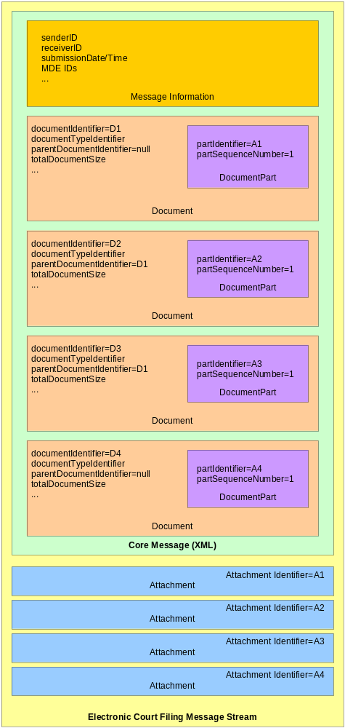
Figure 2. Message Stream with a Document in Multiple Attachments

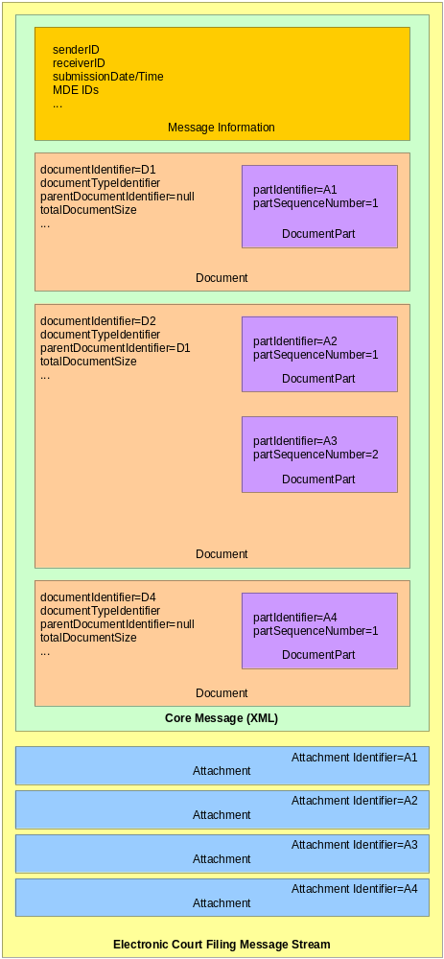
Figure 3. Message Stream With Binary Encoded Document Embedded in the Message

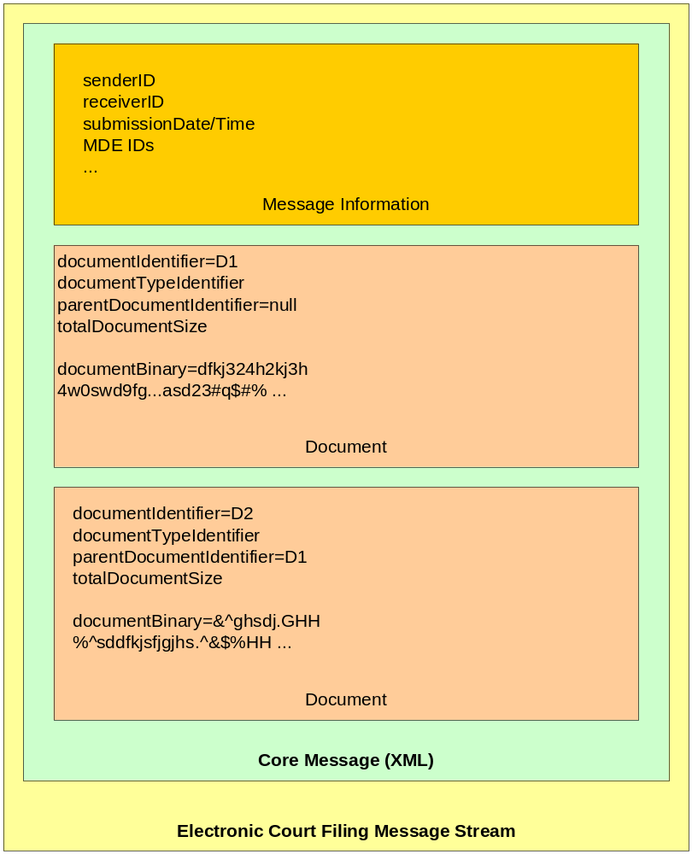

Court Policy
A court’s customary practices may influence many aspects of its ECF 4.0 implementation, and those local practices and variations are expressed through the “court policy” component of e-filing, which includes:
- Human-readable court policy – a textual document publishing the court’s rules and requirements for electronic filing.
- Machine-readable court policy – an ECF 4.0 message that describes the features of the ECF 4.0 implementation supported by this specification, the court’s code lists and any other information a Filing Assembly MDE would need to know in order to successfully submit an electronic filing into that court.
The court MUST have only one active, authoritative version of its human-readable, development-time and run-time policies at a given time; both the human-readable and the machine-readable statements of those policies MUST have the same release dates for the court.
The court’s human-readable and machine-readable court policies MUST each have a version numbering method associated with it. The court’s versioning process SHOULD comply with the following rules: 1) Versions are denoted using a standard triplet of integers: MAJOR.MINOR.PATCH; 2) Different MAJOR versions are to be considered incompatible, large-scale upgrades of the Policy; 3) Different MINOR versions are to be considered to retain source and binary compatibility with earlier minor versions, and changes in the PATCH level are perfectly compatible, forward and backward. It is important to note that a policy that has not reached version 1.0.0 is not subject to the guidelines described in this document. Before a 1.0 release is achieved (i.e., any version numbered 0.x.y), court policy can be changed freely without regard to the restrictions on compatibility between versions.
Court policy is not directly equivalent to “service policy” in the [SOA-RM]. However, thinking about court policy from a policy assertion, policy owner and policy enforcement framework as described in the [SOA-RM] is helpful. Note that “court policy” refers to a set of constituent rules and requirements, while the [SOA-RM] looks at each individual item as a “service policy.” In all cases the policy owner is the court where the document is to be filed. Also note that none of the elements of court policy rise to the level of a “service contract” as defined by the [SOA-RM].

Human-Readable Court Policy
To be compliant with the ECF 4.0 specification, each court MUST publish a human-readable court policy that MUST include each of the following:
- The unique court identifier
- The location of the machine-readable court policy
- A definition of what constitutes a “lead document” in the court
- A description of how the <filingPartyID> and <filingAttorneyID> are to be maintained during electronic communications regarding the case
- A description of how the court processes (dockets) filings
- A description of any instances in which the court will mandate an element that the ECF 4.0 schema makes optional
- A description of any restrictions to data property values other than code list restrictions. (This restriction may be removed in later versions of the ECF specification)
- Any other rules required for electronic filing in the court

Machine-Readable Court Policy
Machine-readable Court Policy includes structures for identifying run-time and development-time policy information.
Run-time information includes information that will be updated from time to time, such as code lists (e.g., acceptable document types, codes for various criminal charges and civil causes of action) and the court’s public key for digital signatures and encryption.
Development-time information includes court rules governing electronic filing that are needed at the time an application is developed but which are not likely to change. These include:
- The service interaction profile(s) that the court supports
- The MDEs, query operations and case types supported by the court’s ECF 4.0 system
- Whether a court will accept the filing of a URL in lieu of the electronic document itself
- Whether the court accepts documents requiring payment of a filing fee
- Whether the court accepts electronic filing of sealed documents
- Whether the court accepts multiple (batch) filings
- The court-specific extensions to the ECF 4.0 specification, including the required elements (see below)
- The maximum sizes allowed for a single attachment and a complete message stream

Court Extensions
The [NIEM] includes a mechanism (see [NIEM Guide]) for defining elements not defined in the [NIEM] and that extension mechanism is used to define all extension elements included in ECF 4.0. Courts MAY use that mechanism to define implementation-specific elements. However, even when ECF 4.0 implementations do not use the [NIEM] extension mechanism, they will NOT be deemed out of compliance with this specification.
The RECOMMENDED approach for defining and including elements that are required by the court but are not supported by, or included in, the ECF 4.0 specification is through a court-specific message using name-value pairs. If the court requires additional elements, the court MUST publish a court-specific message structure in its court policy that clearly defines the additional named elements it requires. The name-value pairs MUST each include a statement of cardinality, as well as a reference to the extension point in the core message or the case-type-specific message, expressed by an XPath substring. Conforming applications that do not understand the court-specific message MAY ignore the message and its content.

Court-Specific Code Lists
Code Lists are used to constrain the allowable values for certain information in an ECF 4.0 message. The court SHOULD provide values for each of the following code lists in its court policy:
- <AliasAlternateNameTypeCode>
- <BinaryFormatText>
- <CardTypeCode>
- <CaseAssociationTypeCode>
- <CaseAttorneyRoleTypeCode>
- <CaseLanguageCode>
- <CaseOrganizationRoleTypeCode>
- <CaseParticipantRelationshipToCaseCode>
- <CasePersonRoleTypeCode>
- <CaseTypeCode>
- <CauseOfActionCode>
- <ChargeAllegationTypeCode>
- <CourtEventTypeCode>
- <DelinquentActApplicabilityText>
- <DelinquentActDegreeText>
- <DelinquentActSeverityText>
- <DelinquentActSpecialAllegationText>
- <DependencyAllegationCode>
- <DriverAuthorizationCommercialClassCode>
- <ErrorCode>
- <FeeExceptionReasonCode>
- <FiduciaryTypeCode>
- <FilingStatusCode>
- <GuardianRelationshipToJuvenileCode>
- <InitiatingPartyCitizenshipTypeText>
- <JurisdictionalGroundsText>
- <NoContactCode>
- <OrganizationRelationshipTypeCode>
- <ParentTypeCode>
- <PaymentMeansCode>
- <PersonEthnicityText>
- <PersonInCustodyIndicator>
- <PersonOrganizationRelationshipTypeCode>
- <PersonRelationshipTypeCode>
- <PhysicalFeatureTypeCode>
- <PlacementTypeCode>
- <ReasonCode>
- <ReliefTypeText>
- <RegisterActionDescriptionText>
- <RequestToVacateCode>
- <RespondingPartyCitizenshipTypeText>
- <ScheduleLocationCode>
- <ServiceStatusCode>
- <StatuteCodeID>
- <StatuteCodeSectionID>
- <StatuteOffenseID>
- <StatusOffenseCodeID>
- <StatusOffenseSectionID>
- <StatusOffenseID>
If a court does not define allowable values for any of the above code lists in court policy, then any value MUST be considered acceptable for that code.

Court-Specific Constraint Schemas

The cardinality of elements in the NIEM subset imported by the ECF is applied through the use of constraint schemas that define the minimum and maximum occurrence of elements in the NIEM subset. Courts MAY enforce court-specific rules and code lists by creating court-specific constraint schemas. This process creating a duplicate set of the ECF schemas and customizing the cardinality of elements as needed. If court-specific constraint schemas are used, instance documents MUST validate against both the ECF schemas and the court constraint schemas.

ECF 4.0 Process Model
This section details the interactions of the ECF 4.0 MDEs and the role of each MDE in the electronic filing and electronic service processes. This section also enumerates the operations provided by each MDE and points to the operations, provided by other MDEs, that each MDE consumes.

The Filing-Preparation-to-Docketing Process Model
This model describes the sequence of operations in a basic filing cycle from Filing Preparation to Docketing. This model involves three parties: a Filer (represented by the Filing Assembly MDE), a Court (represented by the Filing Review and Court Record MDEs) and a Service Recipient (represented by the Legal Service MDE). The operations defined by ECF 4.0 to support the processes in this cycle are listed below. The operations in bold are required and MUST occur in every successful filing as long as sending and receiving MDEs are implemented. The other operations are optional and MAY occur within a given filing:
- GetPolicy
- GetServiceInformation
- GetFeesCalculation
- ReviewFiling
- ServeFiling
- RecordFiling
- NotifyDocketingComplete
- NotifyFilingReviewComplete
At any point during or after the ReviewFiling operation, a party MAY access information through the following operations:
- GetFilingList
- GetFilingStatus
At any point after the NotifyFilingReviewComplete operation, a party MAY access information through the following operations:
- GetCaseList
- GetCase
- GetDocument
These operations are depicted in the sequence diagram below. The solid lines indicate invoked operations and the dashed lines indicate the synchronous responses to those operations.
Figure 4. Filing Preparation to Docketing Process Model
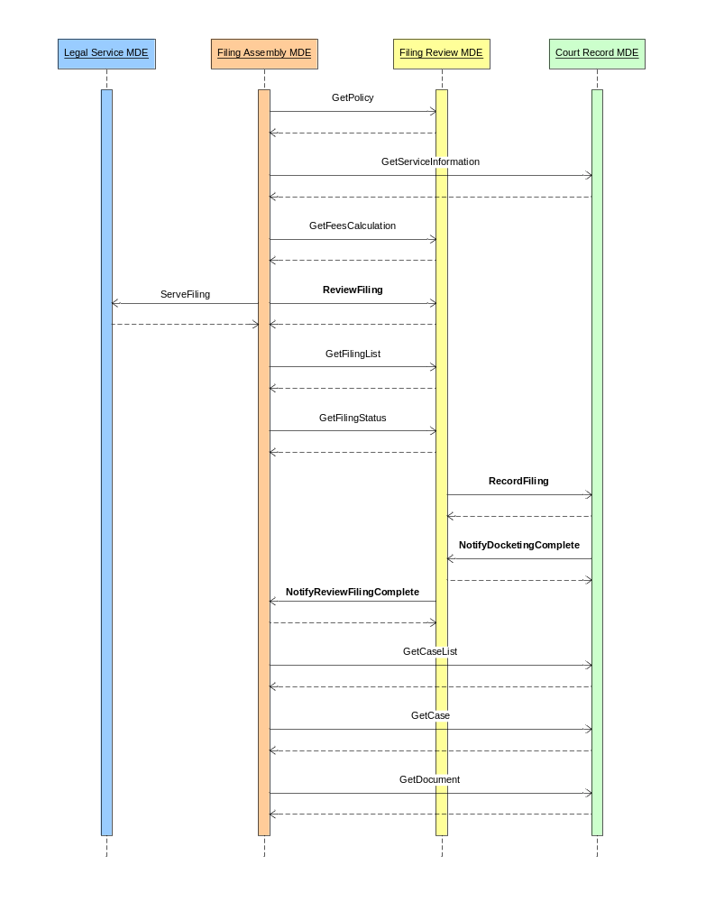

Business Rules
This section describes the business rules of the generic filing-preparation-to-docketing process that govern the ECF 4.0 operations.
ECF 4.0 includes an <ErrorCode> element for returning errors in response to a query request. Successful queries MUST return an <ErrorCode> of “0”. Failed queries MUST NOT return an <ErrorCode> of “0” and SHOULD return an appropriate <ErrorCode> as defined in court policy.

GetPolicy
The Filing Assembly MDE MAY obtain a court’s machine-readable court policy at any time by invoking the GetPolicy operation on the Filing Review MDE with the identifier for the court. The Filing Review MDE returns the machine-readable court policy in a synchronous response. The content of the machine-readable court policy is described in Section 2.4.2. This step may be omitted if the Filing Assembly MDE already has the current court policy.

GetServiceInformation
The Filing Assembly MDE MAY obtain the Court’s service information for all parties in an existing case at any time by invoking the GetServiceInformation operation with the appropriate case number on the Court Record MDE. The service list returned by the GetServiceInformation operation assists the filer in maintaining the filer’s service list and is not a substitute for the filer’s service list. To provide this information, the Court Record MDE MUST have access to the court’s registry with all updated information about case participants. There MUST be only one such registry per court, though multiple courts MAY share the same registry. The Court Record MDE responds synchronously to the Filing Assembly MDE with a service list reflecting the most current contact information available to the court, which is necessary to complete secondary service, whether electronically or by other means.
If the court provides a Hub Service MDE, the electronic service information returned from this query MUST include the court’s Service MDE ID for all case participants who have one.
A party to a case is always the official target of service. In practice, the system will actually deliver to pro se litigants and to attorneys as intermediaries.
The duty to complete secondary service is upon the filer, and not the court, except when the court is the filer.
The GetServiceInformation operation returns a service list current as of the transaction. No assumption can be made that the data returned by the operation will remain current for use at any future point in time.

GetFeesCalculation
The Filing Assembly MDE MAY query for the fees associated with a filing by invoking the MDE’s GetFeesCalculation operation, with a filing as a parameter, on the Filing Review MDE. The Filing Review MDE responds synchronously with the fee calculation and, optionally, a list of the included charges. This step may be omitted if there are no fees associated with filings in the court or the calculated fees are already known.

ReviewFiling
The Filing Assembly MDE MUST submit the filing to the court by invoking the ReviewFiling operation on the Filing Review MDE. The ReviewFiling operation includes messages for the core filing, the case type-specific information, the court-specific information and the filing payment. The Filing Review MDE responds synchronously with a receipt message that includes the filing identifier issued by the court.

ServeFiling
At approximately the same time the Filing Assembly MDE submits the filing to the court, the Filing Assembly MDE MAY serve the entire filing, including core filing, case type-specific and court-specific information, to other parties in the case by invoking the ServeFiling operation on the ServiceMDE associated with the service recipient. This operation MUST NOT be used to serve parties in a new case or to persons or organizations that have not yet been made party to the case. The Legal Service MDE responds synchronously with an acknowledgement that the message will be delivered to the service recipient or with an error.
If the court hosts a hub Service MDE, the Filing Assembly MDE MAY send a message to the hub Service MDE’s ServeFiling operation. The hub Service MDE MUST then broadcast the message to each of the individual Legal Service MDE’s ServeFiling operations and respond synchronously with a single ServiceResponseMessage to the Filing Assembly MDE, conveying the results of each individual service transaction.
If a court chooses to support electronic service, then each Filing Assembly MDE MUST support service operations for the clients for which it provides Filing Assembly functionality.

RecordFiling
If the clerk reviews and accepts the filing, the Filing Review MDE MUST invoke the RecordFiling operation on the Court Record MDE. The RecordFiling operation includes information from the ReviewFiling operation with any modifications or comments by the clerk. The Court Record MDE responds synchronously with an acknowledgement of the request.

NotifyDocketingComplete
The Court Record MDE MUST invoke the NotifyDocketingComplete operation on the Filing Review MDE as a callback message to the RecordFiling operation to indicate whether the filing was accepted or rejected by the court record system. If the Court Record MDE rejected the filing, an explanation MUST be provided. If the Court Record MDE accepts the filing, the docketing information MUST be provided. The Filing Review MDE responds synchronously with an acknowledgement of the callback message.

NotifyFilingReviewComplete
If the clerk rejects the filings or the Filing Review MDE receives the Notify Docketing Complete message, the Filing Review MDE MUST invoke the NotifyFilingReviewComplete operation on the Filing Assembly MDE as a callback message to the ReviewFiling operation to indicate whether the filing was accepted and docketed by the clerk and court record system. The operation MAY return the filed documents or links to the documents, but MUST include the [FIPS 180-2] SHA 256 document hash, a condensed representation of a document intended to protect document integrity.
If the filing included a payment, and the filing was accepted by the clerk and court record system, a receipt for the payment MUST be included in the operation. The Filing Assembly MDE responds synchronously with an acknowledgement of the callback message.

GetFilingList
The Filing Assembly MDE MAY invoke the GetFilingList query operation on the Filing Review MDE to return a list of filings matching several criteria including the filer identifier, the case number and the filed date within a certain time range. The Filing Review MDE responds synchronously with a list of matching filings and the status of each filing.

GetFilingStatus
The Filing Assembly MDE MAY invoke the GetFilingStatus query operation with the filing Identifier on the Filing Review MDE to return the status of the selected filing. The Filing Review MDE responds synchronously with the matching filing and the status of the filing.

GetCaseList
The Filing Assembly MDE MAY invoke the GetCaseList query operation on the Court Record MDE to return a list of cases matching several criteria including case number, case participant, or the filed date over a specific time range. The Court Record MDE responds synchronously with a list of matching cases.

GetCase
The Filing Assembly MDE MAY invoke the GetCase query operation with a case number on the Court Record MDE to return information about the case including the case participants, court docket and calendar events. The Filing Assembly MDE may also limit the amount of case detail returned from the Court Record MDE by using a set of filters. The Court Record MDE responds synchronously with the selected case information.

GetDocument
The Filing Assembly MDE MAY invoke the GetDocument query operation, including the case number and document number, on the Court Record MDE to retrieve a particular document from a case. The Court Record MDE will respond synchronously with the requested document or instructions on how to access it.

Message Business Rules
Each operation includes one or more messages as parameters. The following business rules apply to the content of ECF 4.0 messages:

Identifiers
Identifiers are used to uniquely label people, organizations and things in the ECF 4.0 process. The following conventions will be used to produce identifiers.

Attachment Identifiers
Attachment identifiers MUST be unique within a message transmission. A convention for assigning identifiers to each message and attachment in a message transmission has to be defined in each service interaction profile.

Case Identifiers
Case identifiers (case numbers) are assigned by the court record system and MUST be unique within a court.

Court Identifiers
Court identifiers are locally assigned by the court administrator for a region (typically a state, provincial or federal court administrator) and MUST be universally unique to a court but not necessarily to a particular court house, branch or subunit of a court. Court identifiers MUST conform to following convention:
<Internet domain of the court administrator>:<unique identifier within the court system>.
Examples of conformant court identifiers include:
- courts.wa.gov:superior.king
- nmcourts.com:albd.civil
- uscourts.gov:100
- courts.gov.bc.ca:appeal
These are strictly examples and do not necessarily indicate actual courts.

Document Identifiers
Document identifiers are assigned by the court record system and MUST be unique within a court.

Filing Identifiers
Filing identifiers MUST be unique within a court and will be generated by the court in response to a ReviewFiling operation.

MDE Identifiers
The address of an MDE MUST be unique within a given communications infrastructure. The convention for defining MDE identifiers will be defined in each service interaction profile.

Filer and Party Identifiers
Identifiers for filers and parties to a case, both persons and organizations, MUST be unique within a case and will be generated by the court in response to a ReviewFiling operation.
Attorneys MAY reference the parties they represent with party identifiers. Self-represented litigants MAY be represented using both attorney and party elements for the same individual, with a reference from the attorney element to the party element. The attorney elements for a self-represented litigant SHOULD NOT include a bar number.

Code Lists
Code Lists are used to constrain the allowable values for certain information in a message. The following Code Lists are defined in ECF 4.0 for all implementations. Court-specific code lists are listed in Section 2.4.4.
- <DebtorTypeCode>
- <DocumentLanguageCode.iso639-2b>
- <DrivingAccidentSeverityCode>
- <DrivingRestrictionCode>
- <EstimatedAssetsValueLevelCode>
- <EstimatedDebtsValueLevelCode>
- <FilingStatusCode>
- <IDJurisdictionCode.ncicLIS>
- <MajorDesignElementNameCode>
- <NatureOfDebtCode>
- <NumberOfCreditorsValueLevelCode>
- <OperationNameCode>
- <PersonEyeColorCode>
- <PersonHairColorCode>
- <PersonPrimaryLanguageCode>
- <PersonRaceCode>
- <PersonSexCode>
- <RegistrationJurisdictionCode.ncicLIS>
- <VehicleColorPrimaryCode>
- <VehicleMakeCode>
- <VehicleModelCode>
- <VehicleStyleCode>
- <VehicleRegistrationPlatTypeCode>
- <WarrantExtraditionLimitationCode>

Message-Specific Business Rules
The following business rules apply to specific messages:

CoreFilingMessage
A CoreFilingMessage MUST express the name or names of the party or parties on whose behalf a document is filed,and the party whose document is the subject of a responsive document being submitted for filing. If a case refers to a single element using the legal term “In Re,” the filer SHOULD use the NIEM <CaseRespondentParty>, not the <CaseInitiatingParty> element.
A CoreFilingMessage MAY NOT include documents for transactions such as the payment of a criminal fine. If a CoreFilingMessage includes documents, the message MUST include only one level of connected and supporting documents. If a CoreFilingMessage includes multiple renditions of the same document, the <DocumentContentType> element SHOULD be used to determine how to process multiple renditions of the same document. The <DocumentRenditionMetadata> structure MAY be extended to support more sophisticated workflow processes.

FilingPaymentMessage
ECF 4.0 supports multiple particular payment processes. Information about a payment is included in the FilingPaymentMessage including the method of payment of the applicable fees, e.g., electronic funds transfer, credit or debit card, charge to an escrow account held in the court or promise to pay in the future. The payment may include a maximum amount for the payment if some latitude is needed to accomplish the filing.

RecordDocketingMessage
The court record system SHOULD retain all complete message transmissions, including any message envelopes and headers defined by the service interaction profile, for evidentiary purposes.

ECF 4.0 Schema
The Court Filing XSD schemas are implementations of the ECF 4.0 exchange content models (see Appendix B.3 below). They are the only normative representations of ECF 4.0 messages.
All of the ECF 4.0 XSD schemas are contained in the xsd/ subdirectory of the ECF 4.0 release package (see Appendix A for more information regarding the structure of the release package). The xsd/ directory is further subdivided into xsd/messages/, xsd/common/, xsd/codelist/, xsd/casetype/, xsd/subset/ and xsd/constraint subdirectories.

ECF 4.0 Message Schemas
The XSD schemas defining the basic messages that support the generic ECF 4.0 filing-to-docket process are located in the xsd/messages/ folder, as listed below:

CaseListQueryMessage
xsd/message/ECF-4.0-CaseListQueryMessage.xsd
CaseListResponseMessage
xsd/message/ECF-4.0-CaseListResponseMessage.xsd
CaseQueryMessage
xsd/message/ECF-4.0-CaseQueryMessage.xsd
CaseResponseMessage
xsd/message/ECF-4.0-CaseResponseMessage.xsd
CaseTypeSpecificMessage
xsd/message/ECF-4.0-CaseTypeSpecificMessage.xsd
CoreFilingMessage
xsd/message/ECF-4.0-CoreFilingMessage.xsd
CourtPolicyQueryMessage
xsd/message/ECF-4.0-CourtPolicyQueryMessage.xsd
CourtPolicyReponseMessage
xsd/message/ECF-4.0-CourtPolicyResponseMessage.xsd
CourtSpecificMessage
xsd/message/ECF-4.0-CourtSpecificMessage.xsd
DocumentQueryMessage
xsd/message/ECF-4.0-DocumentQueryMessage.xsd
DocumentResponseMessage
xsd/message/ECF-4.0-DocumentResponseMessage.xsd
FeesCalculationQueryMessage
xsd/message/ECF-4.0-FeesCalculationQueryMessage.xsd
FeesCalculationResponseMessage
xsd/message/ECF-4.0-FeesCalculationResponseMessage.xsd
FilingListQueryMessage
xsd/message/ECF-4.0-FilingListQueryMessage.xsd
FilingListResponseMessage
xsd/message/ECF-4.0-FilingListResponseMessage.xsd
FilingStatusQueryMessage
xsd/message/ECF-4.0-FilingStatusQueryMessage.xsd
FilingStatusResponseMessage
xsd/message/ECF-4.0-FilingStatusResponseMessage.xsd
MessageReceiptMessage
xsd/message/ECF-4.0-MessageReceiptMessage.xsd
NextChunkMessage
xml/ECF-4.0-NextChunkMessage.xsd
NoMoreChunksMessage
xml/ECF-4.0-NoMoreChunksMessage.xsd
PaymentMessage
xsd/message/ECF-4.0-PaymentMessage.xsd
PaymentReceiptMessage
xsd/message/ECF-4.0-PaymentReceiptMessage.xsd
RecordDocketingCallbackMessage
xsd/message/ECF-4.0-RecordDocketingCallbackMessage.xsd
RecordDocketingMessage
xsd/message/ECF-4.0-RecordDocketingMessage.xsd
ReviewFilingCallbackMessage
xsd/message/ECF-4.0-ReviewFilingCallbackMessage.xsd
ServiceInformationQueryMessage
xsd/message/ECF-4.0-ServiceInformationQueryMessage.xsd
ServiceInformationResponseMessage
xsd/message/ECF-4.0-ServiceInformationResponseMessage.xsd
ServiceReceiptMessage
xsd/message/ECF-4.0-ServiceReceiptMessage.xsd

ECF 4.0 Case Type Schemas
The case type schemas defined for ECF 4.0 are included in the xsd/casetype/ directory, as listed below:

AppellateCase
xsd/casetype/ECF-4.0-AppellateCase.xsd
BankruptcyCase
xsd/casetype/ECF-4.0-BankruptcyCase.xsd
CivilCase
xsd/casetype/ECF-4.0-CivilCase.xsd
CriminalCase
xsd/casetype/ECF-4.0-CriminalCase.xsd
DomesticCase
xsd/casetype/ECF-4.0-DomesticCase.xsd
JuvenileCase
xsd/casetype/ECF-4.0-JuvenileCase.xsd
ViolationCase
xsd/casetype/ECF-4.0-ViolationCase.xsd

ECF 4.0 Code List Schemas
The code list schemas required for ECF 4.0 are included in the xsd/codelist/ directory. These code list schemas listed below allow instances conformant to any of the message schemas to be validated against code list values:

DebtorTypeCode
xsd/codelist/ECF-4.0-DebtorTypeCode.xsd
DocumentLanguageCode.iso639-2b
xsd/constraint/jxdm/3.0.3/jxdm.xsd
DrivingAccidentSeverityCode
xsd/constraint/jxdm/3.0.3/jxdm.xsd
DrivingRestrictionCode
xsd/constraint/jxdm/3.0.3/jxdm.xsd
EstimatedAssetsValueLevelCode
xsd/codelist/ECF-4.0-EstimatedAssetsValueLevelCode.xsd
EstimatedDebtsValueLevelCode
xsd/codelist/ECF-4.0-EstimatedDebtsValueLevelCode.xsd
FilingStatusCode
xsd/codelist/ECF-4.0-FilingStatusCode.xsd
IDJurisdictionCode.ncicLIS
xsd/constraint/jxdm/3.0.3/jxdm.xsd
MajorDesignElementNameCode
xsd/codelist/ECF-4.0-MajorDesignElementNameCode.xsd
NatureOfDebtCode
xsd/codelist/ECF-4.0-NatureOfDebtCode.xsd
NumberOfCreditorsValueLevelCode
xsd/codelist/ECF-4.0-NumberOfCreditorsValueLevelCode.xsd
OperationNameCode
xsd/codelist/ECF-4.0-OperationNameCode.xsd
PersonEyeColorCode
xsd/constraint/jxdm/3.0.3/jxdm.xsd
PersonHairColorCode
xsd/constraint/jxdm/3.0.3/jxdm.xsd
PersonPrimaryLanguageCode
xsd/constraint/jxdm/3.0.3/jxdm.xsd
PersonRaceCode
xsd/constraint/jxdm/3.0.3/jxdm.xsd
PersonSexCode
xsd/constraint/jxdm/3.0.3/jxdm.xsd
RegistrationJurisdictionCode.ncicLIS
xsd/constraint/jxdm/3.0.3/jxdm.xsd
VehicleColorPrimaryCode
xsd/constraint/jxdm/3.0.3/jxdm.xsd
VehicleMakeCode
xsd/constraint/jxdm/3.0.3/jxdm.xsd
VehicleModelCode
xsd/constraint/jxdm/3.0.3/jxdm.xsd
VehicleStyleCode
xsd/constraint/jxdm/3.0.3/jxdm.xsd
VehicleRegistrationPlatTypeCode
xsd/constraint/jxdm/3.0.3/jxdm.xsd
WarrantExtraditionLimitationCode
xsd/constraint/jxdm/3.0.3/jxdm.xsd

Service Interaction Profiles
An ECF 4.0 service interaction profile defines a transmission system that supports the functional requirements of electronic filing, along with the MDE operations and message structures, and implements certain non-functional requirements. A service interaction profile does not govern the content of messages – message content is described in Sections 2 and 3 of this specification. A service interaction profile will define how a message gets from the sending MDE to the receiving MDE in a given messaging framework.

Service Interaction Profile Requirements
Each service interaction profile will define standard conventions and configuration details to support interoperability between and among ECF 4.0 implementations that support the same service interaction profile. However, compliance with these requirements will not necessarily guarantee interoperability.
To be compliant with the ECF 4.0 specification, a service interaction profile MUST satisfy the following non-functional requirements:
- Transport protocol – A service interaction profile MUST define how messages are physically transported from a sending MDE to a receiving MDE. In so doing, a profile may identify factors that restrict the range of environments in which the profile is applicable.
- MDE addressing – A service interaction profile MUST include a convention for uniquely addressing each MDE.
- Operation addressing – A service interaction profile MUST describe a convention for uniquely addressing each MDE operation.
- Request and operation invocation – A service interaction profile MUST describe a mechanism for a sending MDE to invoke an operation on the receiving MDE.
- Synchronous mode response – A service interaction profile MUST support synchronous operations in which the response to an operation is always returned immediately, typically within a matter of seconds, to the invoking MDE.
- Asynchronous mode response – A service interaction profile MUST support asynchronous operations in which the response to an operation may not necessarily be returned immediately to the invoking MDE. Instead, the response may be returned at some later time through a callback from the MDE that received the operations to the invoking MDE. The callback MUST include a reference to the invoking message transmission.
- Message/attachment delimiters – A service interaction profile MUST define how the receiving MDE distinguishes messages from attachments within a message transmission.
- Message identifiers – A service interaction profile MUST provide a means for a sending MDE to assign a unique identifier to each message (including any attachments) within a message transmission.
In addition, there are some non-functional features that a service interaction profile SHOULD provide, including:
- Message non-repudiation – A service interaction profile SHOULD provide a mechanism so that the receiving MDE is provided with evidence that demonstrates:
  - the identity of the sending MDE
  - the content of the message(s) transmitted
  - the date and time of the message transmission
- Message integrity – A service interaction profile SHOULD provide a mechanism so that the receiving MDE is able to determine whether the message(s) transmitted (including any attachments) was(were) modified during the message transmission.
- Message confidentiality – A service interaction profile SHOULD provide a mechanism, such as encryption, that can be used with a sending MDE to ensure that the message(s) in a transmission (including any attachments) can be processed only by the receiving MDE.
- Message authentication – A service interaction profile SHOULD provide a mechanism, such that a sending MDE is required to include, to display credentials that demonstrate its identity to the receiving MDE in each message transmission.
- Message transmission reliability – A service interaction profile SHOULD provide a mechanism, such that a sending MDE is required to include, to guarantee that a message transmission will be delivered to the receiving MDE within a specified period of time, or else the sending MDE will receive notification at the end of that period of time that the message transmission was not deliverable to the receiving MDE.
- Message splitting and assembly – A service interaction profile SHOULD provide a mechanism by which a large message can be split into multiple pieces that are transmitted separately by the sending MDE and reassembled into the complete message by the receiving MDE. In the HTTP 1.1 protocol, this is called “chunking.”
- Transmission auditing – A service interaction profile SHOULD provide a mechanism for the MDE to receive message transmissions in their entirety (both messaging and “payload” content) for auditing purposes.

Service Interaction Profile Approval and Revision Processes
The ECF Technical Committee (TC) will recommend certain service interaction profiles for use in implementations of the ECF 4.0 specification. The TC will consider a service interaction profile for recommendation for use in ECF 4.0 implementations provided the profile meets the following requirements:
- The service interaction profile MUST be described in a document in the format of an OASIS specification.
- The service interaction profile specification MUST identify a unique URI to identify the service interaction profile and version.
- The service interaction profile specification MUST describe the binding of MDE operations to the service interaction profile that satisfies the functional requirements described in Section 3 (“ECF 4.0 Process Model”) and Section 4 (“ECF 4.0 Schema”) of this specification.
- The service interaction profile specification MUST demonstrate that the service interaction profile satisfies the non-functional service interaction profile requirements described in Section 5.1 ( “Service Interaction Profile Requirements”) of this specification.
- The service interaction profile specification MUST include samples that demonstrate how the messaging information and “payload” content are combined into message transmissions. These samples MUST include samples that demonstrate both synchronous and asynchronous mode operations.
- At least one voting member of the ECF TC MUST agree to sponsor the service interaction profile and submit the service interaction profile specification to the TC for review as a candidate for approval as an ECF 4.0 compliant service interaction profile.
Certifying that a candidate service interaction profile meets certain service interaction profile requirements will necessarily involve some subjectivity since service interaction profile requirements cannot be expressed algebraically, in the manner of XML Schemas. Therefore, it will be up to the TC to assess whether the proposed profile’s description is adequate in meeting the requirements of ECF 4.0 before approving the service interaction profile specification as a “Committee Draft” through the OASIS standards approval process.
From time to time, it may be necessary to revise or update a service interaction profile to bring it into compliance with changes in network and messaging protocols, or to support additional non-functional requirements. Any revision(s) to previously approved service interaction profiles will be considered a new service interaction profile and MUST meet the requirements of a new service interaction profile, including sponsorship by a voting member of the ECF TC and review and approval by the ECF TC. There will be no guarantees that future versions of a service interaction profile will be backwardly compatible with the current version.

Supported Service Interaction Profiles
The following ECF 4.0 service interaction profile specifications are candidate Committee Drafts for use in conjunction with implementations of the ECF 4.0 specification:
- Web Services Service Interaction Profile 1.0 Specification – This specification defines a transmission system using the specifications described in the Web Services Interoperability (WS-I) Basic Profile 1.1, WS-I Attachments Profile 1.0 and WS-I Basic Security Profile 1.0 (August 29, 2005 Working Draft).
- Portable Media Service Interaction Profile 1.0 Specification – This specification defines a transmission system in which the sending MDE stores message transmissions on portable media (e.g., a compact disc), which is then physically transported to the receiving MDE where it is connected for retrieval of the message transmissions. This specification may be needed in the absence of an active network between the sending and receiving MDEs.
Additional service interaction profiles, or revisions to these service interaction profiles, may be approved by the ECF TC for use in conjunction with implementations of the ECF 4.0 specification according to the process described in Section 5.2 ( “Service Interaction Profile Approval and Revision Processes”) above.

Document Signature Profiles
A ECF 4.0 document signature profile defines a mechanism for asserting that a person signed a single electronic or imaged document, which is an attachment to a message transmission. The signing of an entire message transmission is described in a service interaction profile and is not supported by a document signature profile.

Document Signature Profile Requirements
Each document signature profile will define standard conventions and configuration details to support interoperability in the creation and verification of document signatures between and among ECF 4.0 implementations that support the same document signature profile. However, compliance with these requirements will not necessarily guarantee interoperability.
Except for the Null Document Signature Profile, to be compliant with the ECF 4.0 specification, a document signature profile MUST satisfy the following non-functional requirements:
- Signer name assertion – A document signature profile MUST make an assertion regarding the name of the person who signed a document.
- Signed date assertion – A document signature profile MUST make an assertion regarding the date the person signed a document.
- Multiple signatures – A document signature profile MUST allow multiple signatures to be associated with the same document.
A signature profile SHOULD provide the following non-functional features:
- Signer and date non-repudiation – A document signature profile SHOULD provide a mechanism so that the receiving MDE is provided with verifiable evidence that demonstrates:
  - the unique identity of the person who signed the document
  - the date the person signed a document
- Document integrity – A document signature profile SHOULD provide a mechanism so that the receiving MDE is able to determine if the document was modified since the person signed the document.
- Document signature auditing – A document signature profile SHOULD provide a mechanism for the MDE to receive both the document and signatures for auditing purposes.

Document Signature Profile Approval and Revision Processes
The ECF Technical Committee will recommend certain document signature profiles for use in implementations of the ECF 4.0 specification. The TC will consider a document signature profile for recommendation for use in ECF 4.0 implementations provided the profile meets the following requirements:
- The document signature profile MUST be described in a document in the format of an OASIS specification.
- The document signature profile specification MUST identify a unique URI to identify the document signature profile and version.
- If the document signature is not embedded in the document, the document signature profile specification MUST include an XML structure for describing precisely how the document signature is represented.
- The document signature profile specification MUST demonstrate that the document signature profile satisfies the non-functional requirements described in Section 6.1 ( “Document Signature Profile Requirements”) of this specification.
- The document signature profile specification MUST include samples that demonstrate how the document signature information and “payload” content are combined into message transmissions.
- At least one voting member of the ECF TC MUST agree to sponsor the document signature profile and submit the document signature profile specification to the TC for review as a candidate for approval as an ECF 4.0 document signature profile.
Certifying that a candidate document signature profile meets certain document signature profile requirements will necessarily involve some subjectivity, since document signature profile requirements cannot be expressed algebraically, in the manner of XML Schemas. Therefore, it will be up to the TC to assess whether the proposed profile’s description is adequate to the requirements before approving the profile specification as a Committee Draft through the OASIS standards approval process.
From time to time, it may be necessary to revise or update a document signature profile to bring it into compliance with changes in authentication and encryption protocols, or to support additional non-functional requirements. Any revision(s) to previously approved document signature profiles will be considered a new document signature profile and MUST meet the requirements of a new document signature profile, including sponsorship by a voting member of the ECF TC and review and approval by the ECF TC. There will be no guarantees that future versions of document signature profiles will be backwardly compatible with the current version.

Supported Document Signature Profiles
The following ECF 4.0 document signature profile specifications are candidate Committee Drafts for use in conjunction with implementations of the ECF 4.0 specification:
- Null Document Signature Profile 1.0 Specification – This specification defines a default mechanism to describe documents that do not have any associated signatures.
- XML Document Signature Profile 1.0 Specification – This specification defines a mechanism for associating a W3C XML Signature with a document.
- Application-Specific Document Signature Profile 1.0 Specification – This specification defines a mechanism for embedding an application-specific binary signature with a document. This profile supports the native capabilities in document formats such as Microsoft Word and the Adobe Portable Document Format (PDF) for describing and embedding signatures.
- Proxy Document Signature Profile 1.0 Specification – This specification defines a mechanism for indicating documents that are digitally signed by a court filing infrastructure component on behalf of an authenticated signer.
- Symmetric Key Document Signature Profile 1.0 Specification – This specification defines a mechanism for indicating documents that are digitally signed by a trusted entity on behalf of the signer using a symmetric key known only to the trusted entity.
Additional document signature profiles, or revisions to these document signatures profiles, may be approved by the ECF TC for use in conjunction with implementation of the ECF 4.0 specification according to the process described in Section 6.2 ( “Document Signature Profile Approval and Revision Processes”) above.
- (Informative) Release Notes
  - Availability
Online and downloadable versions of this release are available from the locations specified at the top of this document.
  - Package Structure
The ECF 4.0 specification is published as a ZIP archive named ecf-v4.0.zip. Unzipping this archive creates a directory named ecf-4.0/ containing this specification document and a number of subdirectories. The files in these subdirectories, linked to the specification document, contain the various normative and informational pieces of the 1.0 release. A description of each subdirectory is given below.
art/
Diagrams and illustrations used in this specification
mod/
ECF 4.0 spreadsheet models; see Appendix B.4
uml/
UML exchange content model diagrams; see Appendix B.3
xml/
Example instances; see Appendix D
xsd/
XSD schemas; see Section 4
  - Recursive Structures
Certain components in the [NIEM] version 2.0 schemas allow recursive nesting. For example, a Person may contain other Persons, a Case may be related to another Case, etc. These are legitimate business data structures. Most real-world applications will limit the depth of recursion in such structures, but XSD schemas are incapable of expressing this constraint. Implementers should be aware of this and may wish to set limits on the depth of recursive structures in their applications.
  - Date and Time Formats
The date and time elements contained in the messages defined by the ECF 4.0 XSD schemas should be formatted according to the documentation in the [NIEM] version 2.0. The [NIEM] documentation indicates the following:
- Calendar date values should be expressed as “CCYY-MM-DD”, with an optional time zone qualifier designated by appending -hh:00, where hh represent the number of hours the local time zone is behind Coordinated Universal Time (UTC).
- Time values should be expressed as “hh:mm:ss.sss”, with an optional time zone qualifier designated by appending -hh:00, where hh represent the number of hours the local time zone is behind Coordinated Universal Time (UTC).
These formats are documented in, but not enforced by, the xsd schema at xsd/subset/jxdm/3.0.3/proxy/xsd/1.0/xsd.xsd.
  - Known Errata
Known errors in the ECF 4.0 specification will be identified in an errata document available at:
http://www.oasis-open.org/apps/org/workgroup/legalxml-courtfiling/
- (Informative) ECF 3.0 Development Approach and Artifacts
This appendix describes the approach used to develop ECF 3.0 and the modeling artifacts.
B.1 Principles
The key principles that guided the design of the ECF 3.0 message structures were:
- Interoperability – The ECF 3.0 message structures should provide a means for exchanging court filings among all types of court information systems.
- Completeness – The ECF Filing 3.0 message structures format should provide for all the elements of an electronic filing system.
- Simple implementation – The design should foster rapid implementation.
- Simple XML and portable structure – The core messages in an ECF 3.0 exchange will be formatted as XML documents.
- Familiarity – The data elements and code values should be meaningful to the legal community and non-expert recipients alike.
- Interdisciplinary and international utility – The design should be usable by a broad range of court-related applications and should be applicable internationally.
B.2 Approach
The ECF 3.0 message schemas were developed as a [NIEM] Information Exchange Package Definition (IEPD). An IEPD is a collection of artifacts that describe the structure and content of a set of data that is transmitted for a specific business purpose. It does not specify other interface layers (such as Web services). It is prefixed with “G” to indicate that the IEPD is NIEM-conformant. [NIEM IEPD]
The NIEM Naming and Design Rules (MNDR) [NIEM MNDR] describe best practices for the development of NIEM-conformant Information Exchange Packages and documentation. The Design Rules set forth:
- A methodology for the construction of [NIEM]-conformant exchange documents
- Naming and design rules for the artifacts called for by the methodology
- Guidelines for the customization of [NIEM] schema structures
B.3 ECF 4.0 Exchange Content Models
The ECF 4.0 exchange content models describe the information components used in all of the messages defined by ECF 4.0.
The exchange content models are the result of a detailed analysis of the data requirements to support the ECF 4.0 Process Model (see Section 3). During the modeling process, common items of data were identified by a process of normalization to identify aggregates based on functional dependency. Where appropriate, these were generalized so that they could be re-used to support the various messages.
The exchange content models are used for the following purposes:
- They facilitate the identification of the reusable components, i.e., the data structures that are common across the ECF 4.0 messages.
- They aid in understanding the information requirements of the total scenario.
- They are the source from which the object classes are derived and documented in the ECF 3.0 schemas (see Section 4).
To facilitate comprehension, the ECF 3.0 is composed of several exchange content model diagrams. Each diagram represents a logical grouping of components and displays both the attributes and object classes belonging to the components in this grouping. The scope of each diagram is arbitrary and does not hold any significance beyond these diagrams.
For example, the ECF 4.0 Review Filing Model diagram is shown below:

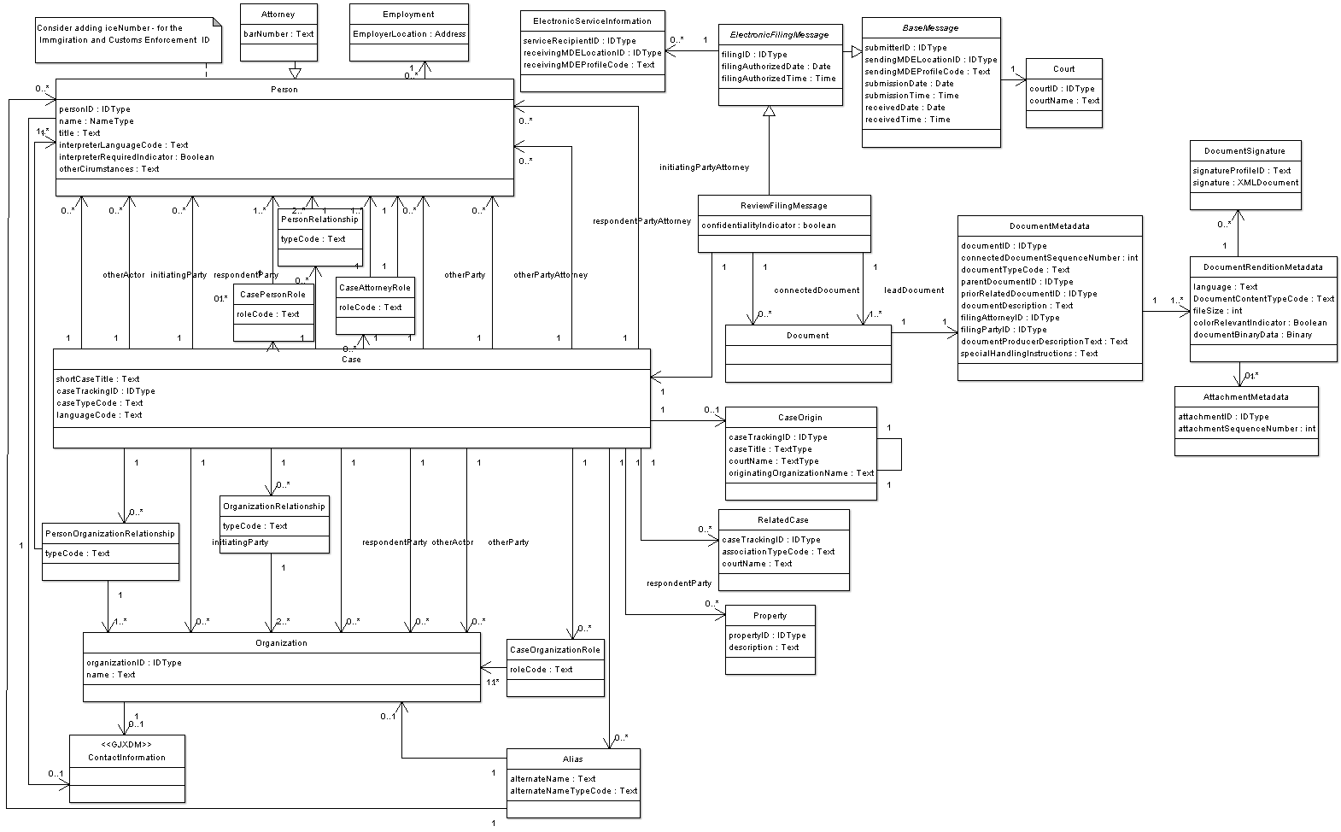

The complete set of exchange content models for all the ECF 4.0 components is listed below:

Appellate Filing Model
uml/html/AppellateFiling.png
Bankruptcy Filing Model
uml/html/BankruptcyFiling.png
Base Message Model
uml/html/BaseMessage.png
Civil Filing Model
uml/html/CivilFiling.gif
Criminal Filing Model
uml/html/CriminalFiling.png
Domestic Filing Model
uml/html/DomesticFiling.png
Extended Person Information Model
uml/html/ExtendedPersonInformation.png
Get Calculated Fees Query Model
uml/html/GetFeesCalculationQuery.png
Get Case List Query Model
uml/html/GetCaseListQuery.png
Get Document Query Model
uml/html/GetDocumentQuery.png
Get Filing List Query Model
uml/html/GetFilingListQuery.png
Get Filing Status Query Model
uml/html/GetFilingStatusQuery.png
Get Service Information Query Model
uml/html/GetServiceInformationQuery.png
Major Design Elements Model
uml/html/MajorDesignElements.png
Juvenile Filing Model
uml/html/JuvenileFiling.png
Record Docketing Model
uml/html/RecordDocketing.png
Review Filing Model
uml/html/ReviewFiling.png
Violation Filing Model
uml/html/Violation Filing.png

No specific directions are defined for the associations in these models; they can be navigated in either direction. The specific navigation path for each association is defined when documents are assembled.
B.4 Spreadsheet Models
ECF 4.0 uses spreadsheet models to describe the mapping of objects and attributes to [NIEM] and ECF 4.0 elements. There is a separate model, on a separate tab in the spreadsheet model, for each domain model diagram. The spreadsheet models use rows to define components. Components are either simple data types or associations. Columns define the metadata associated with each component type.

The ECF 4.0 spreadsheet model is located at mod/ECF-4.0-NIEM-mapping.xls.

- (Informative) MDE Operations
This appendix details the operations that are provided by each Major Design Element (MDE) and the operations, provided by other MDEs, that each MDE “consumes.” Implementation of an MDE requires both that the MDE provide certain functionality and that the MDE use particular operations provided by other MDEs.
C.1 Filing Assembly MDE
The Filing Assembly MDE supports the preparation and submission of filed documents to a court for review, and can receive the results of that process. The Filing Assembly MDE also conveys filings to the Legal Service MDE for service on other case participants. The Filing Assembly MDE calls operations in other MDEs and provides a single operation for notifying the submitter that the filing has been reviewed by a court. A Filing Assembly MDE may be provided by a court or by a third party.
C.1.1 Provided Operations
The Filing Assembly MDE provides the following operations to other MDEs:
Operation | Called By | Output | Parameters
NotifyFilingReviewComplete | Filing Review MDE | xsd/message/ECF-4.0-MessageReceiptMessage.xsd : MessageReceiptMessage | xsd/message/ECF-4.0-ReviewFilingCallbackMessage.xsd : ReviewFilingCallbackMessage
NotifyFilingReviewComplete | Filing Review MDE |  | xsd/message/ECF-4.0-CaseTypeSpecificMessage.xsd : CaseTypeSpecificMessage
NotifyFilingReviewComplete | Filing Review MDE |  | xsd/message/ECF-4.0-CaseTypeSpecificMessage.xsd : CourtSpecificMessage
NotifyFilingReviewComplete | Filing Review MDE |  | xsd/message/ECF-4.0-PaymentMessage.xsd : PaymentMessage
C.1.2 Consumed Operations
The Filing Assembly MDE calls the following operations in other MDEs:
Operation | Provided By | Return Type
GetPolicy | Filing Review MDE | xsd/message/ECF-4.0-CourtPolicyQueryMessage.xsd : CourtPolicyReponseMessage
ReviewFiling | Filing Review MDE | xsd/message/ECF-4.0-MessageReceiptMessage.xsd : MessageReceiptMessage
GetFeesCalculation | Filing Review MDE | xsd/message/ECF-4.0-FeesCalculationResponseMessage.xsd : FeesCalculationResponseMessage
GetFilingStatus | Filing Review MDE | xsd/message/ECF-4.0-FilingStatusResponseMessage.xsd : FilingStatusResponseMessage
GetFilingList | Filing Review MDE | xsd/message/ECF-4.0-FilingListResponseMessage.xsd : FilingListResponseMessage
GetCase | Court Record MDE | xsd/message/ECF-4.0-CaseResponseMessage.xsd : CaseResponseMessage
GetCaseList | Court Record MDE | xsd/message/ECF-4.0-CaseListResponseMessage.xsd : CaseListResponseMessage
GetServiceInformation | Court Record MDE | xsd/message/ECF-4.0-ServiceInformationResponseMessage.xsd : ServiceInformationResponseMessage
GetDocument | Court Record MDE | xsd/message/ECF-4.0-DocumentResponseMessage.xsd : DocumentResponseMessage
ServeFiling | Legal Service MDE | xsd/message/ECF-4.0-ServiceReceiptMessage.xsd : ServiceReceiptMessage
C.2 Filing Review MDE
The Filing Review MDE receives, presents and manages the filings. The Filing Review MDE receives filings in a standard format and presents those filings to a Clerk for review, where they may be accepted or rejected. The Filing Review MDE transmits data and documents to the Filing Assembly MDE to inform the filer that the filing has been accepted or rejected. The Filing Review MDE transmits data and documents for accepted filings to the Court Record MDE for docketing and recording. While there will generally be one Filing Review MDE per court, there is no physical barrier to having more than one, particularly if a court wants to support different Filing Review MDEs for particular case types.
C.2.1 Provided Operations
The Filing Review MDE provides the following operations to other MDEs:
Operation | Called By | Output | Parameters
ReviewFiling | Filing Assembly MDE | xsd/message/ECF-4.0-MessageReceiptMessage.xsd : MessageReceiptMessage | xsd/message/ECF-4.0-CoreFilingMessage.xsd : CoreFilingMessage
ReviewFiling | Filing Assembly MDE |  | xsd/message/ECF-4.0-CaseTypeSpecificMessage.xsd : CaseTypeSpecificMessage
ReviewFiling | Filing Assembly MDE |  | xsd/message/ECF-4.0-CaseTypeSpecificMessage.xsd : CourtSpecificMessage
ReviewFiling | Filing Assembly MDE |  | xsd/message/ECF-4.0-PaymentMessage.xsd : PaymentMessage
NotifyDocketingComplete | Court Docketing MDE | xsd/message/ECF-4.0-MessageReceiptMessage.xsd : MessageReceiptMessage | xsd/message/ECF-4.0-RecordDocketingCallbackMessage.xsd : RecordDocketingCallbackMessage
NotifyDocketingComplete | Court Docketing MDE |  | xsd/message/ECF-4.0-CaseTypeSpecificMessage.xsd : CaseTypeSpecificMessage
NotifyDocketingComplete | Court Docketing MDE |  | xsd/message/ECF-4.0-CaseTypeSpecificMessage.xsd : CourtSpecificMessage
GetFeesCalculation | Filing Assembly MDE | xsd/message/ECF-4.0-FeesCalculationResponseMessage.xsd : FeesCalculationResponseMessage | xsd/message/ECF-4.0-FeesCalculationQueryMessage.xsd : FeesCalculationQueryMessage
GetFilingList | Filing Assembly MDE | xsd/message/ECF-4.0-FilingListResponseMessage.xsd : FilingListResponseMessage | xsd/message/ECF-4.0-FilingListQueryMessage.xsd : FilingListQueryMessage
GetFilingStatus | Filing Assembly MDE | xsd/message/ECF-4.0-FilingStatusResponseMessage.xsd : FilingStatusResponseMessage | xsd/message/ECF-4.0-FilingStatusQueryMessage.xsd : FilingStatusQueryMessage
GetPolicy | Filing Assembly MDE | xsd/message/ECF-4.0-CourtPolicyQueryMessage.xsd : CourtPolicyReponseMessage | xsd/message/ECF-4.0-CourtPolicyQueryMessage.xsd : CourtPolicyQueryMessage
C.2.2 Consumed Operations
The Filing Review MDE calls the following operations in other MDEs:
Operation | Provided By | Output
RecordFiling | Court Record MDE | xsd/message/ECF-4.0-MessageReceiptMessage.xsd : MessageReceiptMessage
NotifyFilingReviewComplete | Filing Assembly MDE | xsd/message/ECF-4.0-MessageReceiptMessage.xsd : MessageReceiptMessage
C.3 Court Record MDE
The Court Record MDE receives, presents and manages the filed documents for entry into the official case record of the court. The Court Record MDE receives filed documents, presenting them to a Clerk for docketing (processing), during which they will be accepted or rejected by the court record system. The Court Record MDE transmits information and/or documents to the Filing Review MDE to inform the reviewer whether the filing has been accepted or rejected.
C.3.1 Provided Operations
The Court Record MDE provides the following operations to other MDEs:
Operation | Called By | Output | Parameters
RecordFiling | Filing Review MDE | xsd/message/ECF-4.0-MessageReceiptMessage.xsd : MessageReceiptMessage | xsd/message/ECF-4.0-RecordDocketingMessage.xsd : RecordDocketingMessage
RecordFiling | Filing Review MDE |  | xsd/message/ECF-4.04.0-CoreFilingMessage.xsd : CoreFilingMessage
RecordFiling | Filing Review MDE |  | xsd/message/ECF-4.0-CaseTypeSpecificMessage.xsd : CaseTypeSpecificMessage
RecordFiling | Filing Review MDE |  | xsd/message/ECF-4.0-CaseTypeSpecificMessage.xsd : CourtSpecificMessage
GetCase | Filing Assembly MDE | xsd/message/ECF-4.0-CaseResponseMessage.xsd : CaseResponseMessage | xsd/message/ECF-4.0-CaseQueryMessage.xsd : CaseQueryMessage
GetCaseList | Filing Assembly MDE | xsd/message/ECF-4.0-CaseListResponseMessage.xsd : CaseListResponseMessage | xsd/message/ECF-4.0-CaseListQueryMessage.xsd : CaseListQueryMessage
GetServiceInformation | Filing Assembly MDE | xsd/message/ECF-4.0-ServiceInformationResponseMessage.xsd : ServiceInformationResponseMessage | xsd/message/ECF-4.0-ServiceInformationQueryMessage.xsd : ServiceInformationQueryMessage
GetDocument | Filing Assembly MDE | xsd/message/ECF-4.0-DocumentResponseMessage.xsd : DocumentResponseMessage | xsd/message/ECF-4.0-DocumentQueryMessage.xsd : DocumentQueryMessage
C.3.2 Consumed Operations
The Court Record MDE calls the following operations in other MDEs:
Operation | Provided By | Output
NotifyDocketingComplete | Filing Review MDE | xsd/message/ECF-4.0-MessageReceiptMessage.xsd : MessageReceiptMessage
C.4 Legal Service MDE
The Legal Service MDE enables a filer or a court to electronically transmit copies of, or links to, electronically filed documents to other parties who are participating in the case and who are entitled to be promptly served with the electronically filed documents. The Legal Service MDE transmits data and documents to the Filing Assembly MDE to inform the case participant that an electronic filing has been submitted to the court clerk. The Legal Service MDE transmits a callback message to the Filing Assembly MDE requesting a notification to confirm receipt of the served document.
C.4.1 Provided Operations
The Legal Service MDE provides the following operations to other MDEs:
Operation | Called By | Output | Parameters
ServeFiling | Filing Assembly MDE | xsd/message/ECF-4.0-ServiceReceiptMessage.xsd : ServiceReceiptMessage | xsd/message/ECF-4.0-CoreFilingMessage.xsd : CoreFilingMessage
ServeFiling | Filing Assembly MDE |  | xsd/message/ECF-4.0-CaseTypeSpecificMessage.xsd : CaseTypeSpecificMessage
ServeFiling | Filing Assembly MDE |  | xsd/message/ECF-4.0-CaseTypeSpecificMessage.xsd : CourtSpecificMessage
C.4.2 Consumed Operations
The Legal Service MDE does not call operations in other MDEs.

- (Informative) Guidance on Implementing Electronic Service
Brian Hickman will suggesting alternative methods (best practices) for courts and vendors to implement service, including a multi-vendor environment model.
- (Informative) Example Instances
Example instances of each ECF 4.0 message are provided in the xml/ subdirectory, as listed below:

FeesCalculationQueryMessage
xml/ECF-4.0-FeesCalculationQueryMessage-Example.xml
FeesCalculationResponseMessage
xml/ECF-4.0-FeesCalculationResponseMessage-Example.xml
CaseListQueryMessage
xml/ECF-4.0-CaseListQueryMessage-Example.xml
CaseListResponseMessage
xml/ECF-4.0-CaseListResponseMessage-Example.xml
CaseQueryMessage
xml/ECF-4.0-CaseQueryMessage-Example.xml
CaseResponseMessage
xml/ECF-4.0-CaseResponseMessage-Example.xml
CaseTypeSpecificMessage
xml/ECF-4.0-CaseTypeSpecificMessage-Example.xml
CoreFilingMessage
xml/ECF-4.0-CoreFilingMessage-Example.xml
CourtPolicyQueryMessage
xml/ECF-4.0-CourtPolicyQueryMessage-Example.xml
CourtPolicyReponseMessage
xml/ECF-4.0-CourtPolicyResponseMessage-Example.xml
CourtSpecificInformation
xml/ECF-4.0-CourtSpecificMessage-Example.xml
DocumentQueryMessage
xml/ECF-4.0-DocumentQueryMessage-Example.xml
DocumentResponseMessage
xml/ECF-4.0-DocumentResponseMessage-Example.xml
FilingListQueryMessage
xml/ECF-4.0-FilingListQueryMessage-Example.xml
FilingListResponseMessage
xml/ECF-4.0-FilingListResponseMessage-Example.xml
FilingPaymentMessage
xml/ECF-4.0-PaymentMessage-Example.xml
FilingStatusQueryMessage
xml/ECF-4.0-FilingStatusQueryMessage-Example.xml
FilingStatusResponseMessage
xml/ECF-4.0-FilingStatusResponseMessage-Example.xml
MessageReceiptMessage
xml/ECF-4.0-MessageReceiptMessage-Example.xml
NextChunkMessage
xml/ECF-4.0-NextChunkMessage-Example.xml
NoMoreChunksMessage
xml/ECF-4.0-NoMoreChunksMessage-Example.xml
PaymentReceiptMessage
xml/ECF-4.0-PaymentReceiptMessage-Example.xml
RecordDocketingCallbackMessage
xml/ECF-4.0-RecordDocketingCallbackMessage-Example.xml
RecordDocketingMessage
xml/ECF-4.0-RecordDocketingMessage-Example.xml
ReviewFilingCallbackMessage
xml/ECF-4.0-ReviewFilingCallbackMessage-Example.xml
ServiceInformationQueryMessage
xml/ECF-4.0-ServiceInformationQueryMessage-Example.xml
ServiceInformationResponseMessage
xml/ECF-4.0-ServiceInformationResponseMessage-Example.xml
ServiceReceiptMessage
xml/ECF-4.0-ServiceReceiptMessage-Example.xml

- (Informative) Ongoing Work Items
The Electronic Court Filing TC plans to continue to revise and expand this specification through future versions. Future versions of ECF will:

- Address filings in administrative tribunals
- Address primary service (the delivery of documents such as summonses, subpoenas and warrants that establish a court’s jurisdiction over a party)
- Consider how the specifications for filing of documents intended for filing with a court relate to specifications for filing other documents, e.g., property records, in the offices of elected clerks of courts
- Incorporate feedback from ECF implementations
- Support future releases of the [NIEM]
- Support future [Court Document] specifications and integration optimizations

- Support non-case related filings into a court clerk’s office

- (Informative) Acknowledgments
The following court organizations provided lists of data elements required for initiating cases in their case management information systems:
Administrative Office of United States Courts
Bankruptcy, Civil, Criminal
Fourth Judicial District Court, Hennepin County, Minneapolis
Criminal
King County Superior Court, Washington
Civil, Criminal
Missouri Office of State Courts Administrator
Traffic
Thirteenth Judicial District, Orange County, Florida (through vendor)
Civil, Criminal, Domestic relations, Mental health, Juvenile delinquency/dependency, Probate, Traffic
Utah State Courts (through vendor)
Civil, Criminal

The following individuals were members or voting members of the committee during the approval of this draft:
Participants:
Michael Alexandrou, Judicial Council of Georgia
Adam Angione, Courthouse News Service
Donald Bergeron, Reed Elsevier
James Cabral, MTG Management Consultants, LLC.
Rolly Chambers, American Bar Association
James Bryce Clark, OASIS
Thomas Clarke, National Center for State Courts
James Cusick, Wolters Kluwer
Robert DeFilippis, Individual Member
Christopher Durham, Reed Elsevier
Scott Edson, LA County Information Systems Advisory Body
Robin Gibson, Missouri Office of State Courts Administrator
David Goodwin, Maricopa County
Gary Graham, Arizona Supreme Court
John Greacen, Individual Member
Jim Harris, Individual Member
Brian Hickman, Wolters Kluwer
Hui Ji, Judicial Council of Georgia
Mark Ladd, Property Records Industry Association
Laurence Leff, Individual Member
Rex McElrath, Judicial Council of Georgia
John Messing, American Bar Association
Robert O'Brien, Ottawa Courts Administration Service
Gary Pointdexter, Individual Member
Nick Pope, Thales eSecurity Ltd.
Catherine Plummer, Search Group, Inc.
Nick Pope, Individual Member
David Roth, Thomson Corporation
John Ruegg, LA County Information Systems Advisory Body
Christopher Smith, California Administrative Office of the Courts

- (Informative) Revision History
Rev | Date | By Whom | What
Wd-1 | 2008-03-17 | James Cabral | Initial version

The Technical Committee chose ECF 3.0 over ECF 2.0 to indicate this specification’s close relationship to and dependency on Version 3 of the Global Justice XML Data Model.
http://www.oasis-open.org/committees/download.php/1023/UBL%3A%20The%20Next%20Step%20for%20Global%20E-Commerce
http://xml.coverpages.org/xmlSig.html

