ECF5 Spec Feedback and Considerations – 9
This document contains additional questions and commentary resulting from a review at the Electronic Court Filing Version 5.0 Working Draft 14. The purpose of this document is to gather together loose ends from issues raised in prior feedback documents. Excluded from this overlooked or pending issue round up are issues addressed in the May 23, 2017 work group conference call (see ECF5 Spec Considerations-8.docx). Also excluded are issues related to participant role codes, participant types and participant identifiers, etc. These issues are interrelated and are expected to be addressed in a separate upcoming work session.

- PayerNameText

Per NIEM NDR rule 12-5, ecf:PayerNameText needs to be revised to be of type nc:PersonType. See feedback document 4, item #2.

- ChildSupportEnforcementCase

This item addresses the response to the question from feedback document 2, item #7. Both the question and the response are copied below:

Note: it’s still not clear why ChildSupportEnforcementCase is implemented by substitution for nc:Case (ecf-4 style), whereas appellate case, bankruptcy case, citation case, civil case, criminal case domestic case, and juvenile case are provided by substitution for nc:CaseAugmentationPoint.

In ECF 5, cyfs:ChildSupportEnforcementCase is contained within domestic:CaseAugmentation. While the NIEM allows it to substitute for nc:Case, it is not intended to be used that way in ECF 5.

The response above explains why ChildSupportEnforcementCase appears as it does in the illustration below from XMLSpy:

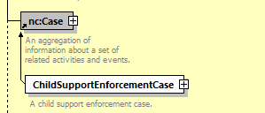

Since schema permits substituting ChildSupportEnforcementCase for nc:Case, but since this is not what should be done in ECF5 (instead it should be substituted for nc:CaseAugmentationPoint), then we should add a specification rule that the nc:Case substitution is not allowed?

The next 5 items were originally raised in feedback document 5, but no responses were ever provided. It was easy enough to verify that the type in section 6.2.5 has not been corrected by wd14, so all 5 issues are repeated here:

- Typo
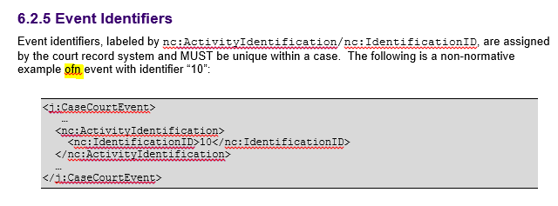

- DocumentPostDate

Okay, I initially thought that nc:DocumentPostDate had been removed in ECF5, however I now see that it has been relocated.

But isn’t it in the wrong place now?

In ECF5, it now does not appear until after both j:CaseCourt and nc:DocumentInformationCutOffDate (which has also been relocated).

However, in NIEM, nc:DocumentPostDate should appear before nc:DocumentReceivedDate as it did under ECF4.

DocumentInformationCutOffDate should appear immediately following nc:DocumentIdentiifcation.

- DocumentStatus absent

ECF4 provides nc:DocumentStatus. This element is missing in ECF5.

This element is currently used in Arizona (in NotifyDocketingComplete – RecordDocketingCallbackMessage):

6.5 nc:DocumentStatus

Standard Definition: DocumentStatus is a status of a document.

AOC Usage Notes: This is the directive set in clerk review that describes the overall submission review completeness. This is used to identify when review of all documents in a CFM has been completed. This element may be used in a multi-episode clerk review scenario to identify RecordDocketingCallbackMessages (RDCM) resulting from the final review operation.

This element MUST be provided for all RDCBMs. The value provided in nc:StatusText MUST be the same for all RDCBMs within the NDC.

Example:
<nc:DocumentStatus>
<nc:StatusText>SubmissionFullyReviewed</nc:StatusText>
<nc:StatusDate>
<nc:DateTime>2011-08-24T02:34:22-07:00</nc:DateTime>
</nc:StatusDate>
<nc:StatusDescriptionText>SubmissionFullyDocketed</nc:StatusDescriptionText>
</nc:DocumentStatus>

- FilingMessageTypeAugmentationPoint?

Is the augmentation point in filing:FilingMessageType correctly named nc:DocumentAugmentationPoint or should it be named like FilingMessageAugmentationPoint?

Does the name of an augmentation point affect the allowed substitutions? If renamed as suggested above, could DocumentAugmentation still be substituted for the renamed augmentation point?

Regardless of the name of the augmentation point in filing:FilingMessageType, is the content of DocumentAugmentation appropriate for FilingMessageType?

Aside from a couple (e.g. ecf:SpecialHandlingInstructionsText, nc:Metadata), these elements in DocumentAugmentation do not appear appropriate for FilingMessageType, but would be appropriate for nc:DocumentType.

- RedactionRequiredIndicator

There seems to be a typo in the definition for RedactionRequiredIndicator – “Indicator by the filer that the document must be redacted nu the court.”

- Xxx

