ECF5 Spec Feedback and Considerations – 26

This document provides additional ECF-5 feedback, questions, and commentary. This feedback is based on review of the Electronic Court Filing Version 5.0 Working Draft 31 (WD31), unless otherwise noted. This document does not represent a comprehensive review of WD31 but instead only raises issues uncovered during a limited review time interval. Additional review of WD31, or other future work draft(s), is anticipated as additional time permits.

- Self-Represented Litigant

Section 6.5 includes: Parties not represented by an attorney should be represented with ecf:CaseParty and the ecf:CaseParticipantRoleCode value “SelfRepresentedLitigant”.

As of WD30, the ecf:CaseParticipantRoleCode of “SelfRepresentedLitigant” has been replaced by the new ecf:CasePartyRepresentationIndicator with a value of “true”.

- Filing Identifier

In WD31, section ‘6.2.4 Message and Filing Identifiers’ was split out into two sections. In doing so, an error was introduced into the specification document in sections 6.2.4 and 6.2.5.

In 6.2.4 includes:

When describing a filing identifier, nc:DocumentIdentification
• MUST include nc:IdentificationSourceID with the value of the filing identifier, and

Section 6.2.5 includes:

When describing a message identifier, nc:DocumentIdentification MUST include:
• nc:IdentificationSourceID with the value of the message identifier, and

In both sections the correct element is nc:IdentificationID and not nc:IdentificationSourceID (as shown in the associated non-normative examples).

- GetFilingList

The recent revision in the WD31 specification document, section 6.2.4 provides:

“An e-filing transaction is the set of messages associated with the operations in Figure 1. Filing and Service Process beginning with ReviewFiling and ending with ServeProcess.”

Figure 1 is shown below:
- 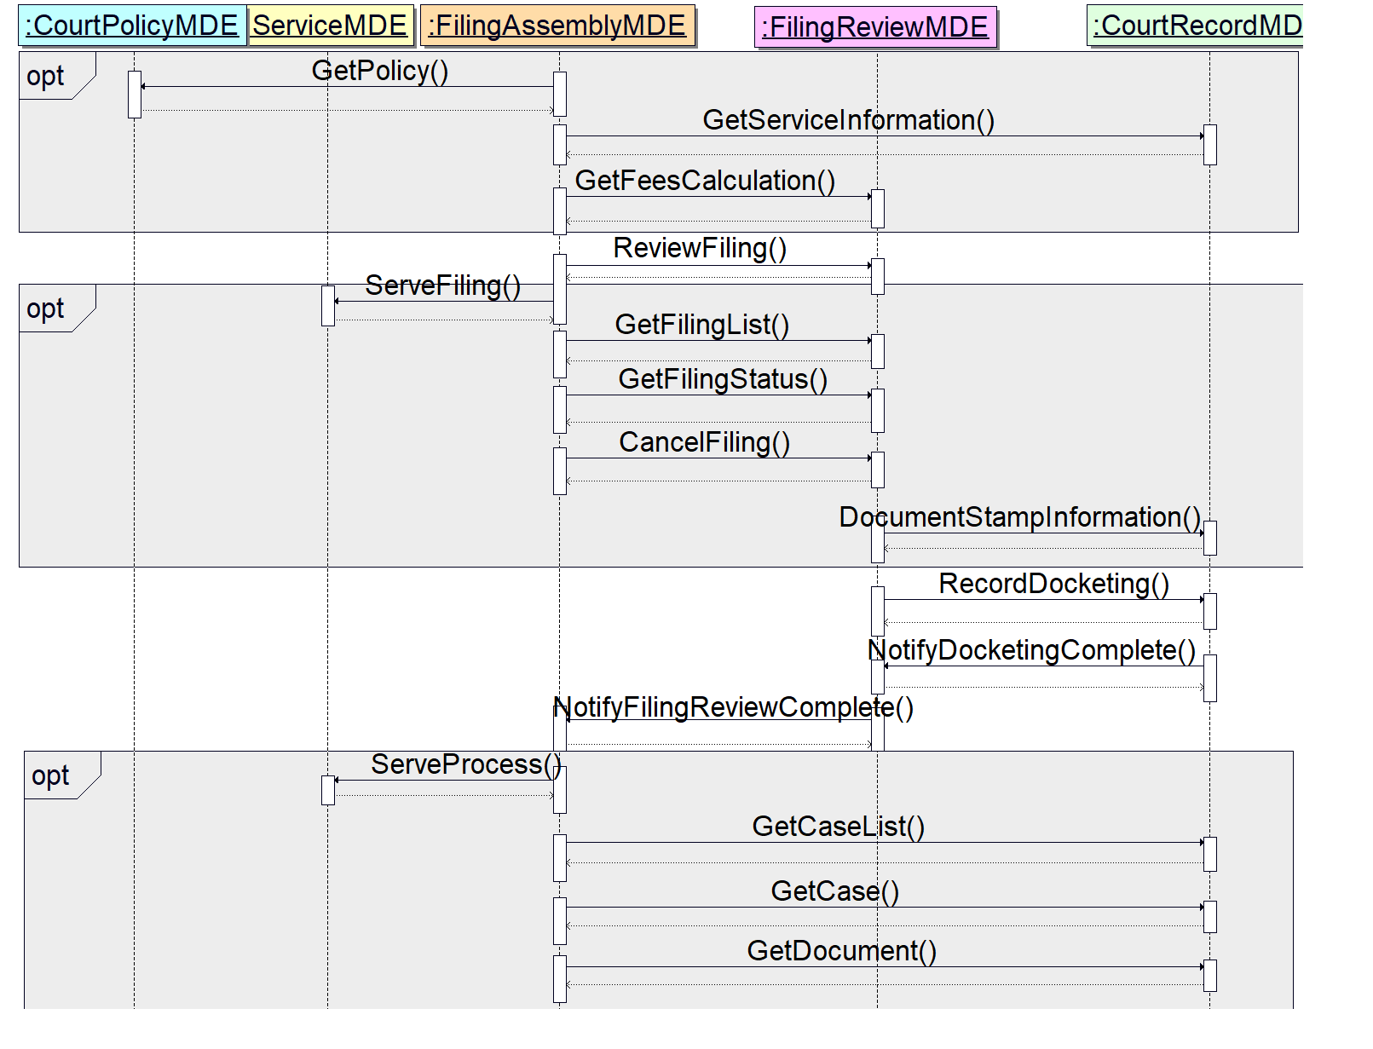
Of course it is not true that the [ECF] filing identifier will or must be present in all messages in the e-filing transaction; the [ECF] filing identifier will not be present within the filing:FilingMessage in the ReviewFilingRequest, and will never be present in any PaymentMessage.

Furthermore, since ServeFiling and ServeProcess can be invoked before ReviewFiling is invoked (and hence before the assignment of the [EFM] filing identifier) then even though these operations may be within the e-filing transaction, they cannot contain the [ECF] filing identifier!

- GetFilingList

Also, as described and illustrated above (#3), both GetFilingList and GetFilingStatus would be within the “e-filing transaction”.

Also specified in section 6.2.4:

“A filing identifier is a unique value assigned to an e-filing transaction by the FilingReview MDE during the ReviewFiling operation. The same filing identifier MUST be included in all subsequent request and response messages in the e-filing transaction.”

This appears to require that the [ECF] filing identifier MUST be included in the GetFilingListRequestMessage (e.g. as shown below).

<nc:DocumentIdentification>
<!-- Filing Identifier assigned by the FRMDE. -->
<nc:IdentificationID>123456ABC</nc:IdentificationID>
<nc:IdentificationCategoryDescriptionText>filingID</nc:IdentificationCategoryDescriptionText>
<nc:IdentificationSourceText>FilingReview</nc:IdentificationSourceText>
</nc:DocumentIdentification>

As such, then a GetFilingListRequest MUST only be for a single filing. As such, then what is the purpose of ecf:CaseTrackingID, j:CaseNumberText, nc:DateRange, and nc:DocumentSubmitter?

My understanding was that these elements were provided as query parameters, so that one or more filings could be specified when the ECF filing identifier was unknown. The availability of these elements suggests that the [ECF] filing identifier should be optionally provided when invoking a GetFilingListRequest. If so, then GetFilingListRequest must not be subject to the provision that “the same filing identifier MUST be included …” provision.

Also, once the e-filing transaction has concluded, either by ServeProcess (which is optional) or through the last NotifyFilingReviewComplete operation for an e-filing submittal, then are GetFilingList and GetFilingStatus requests no longer supported for the concluded e-filing transaction?

- E-Filing Transaction Scope

One possible outcome in addressing the above issues, is that GetFilingList and/or GetFilingStatus operations are not included in the scope of “request and response messages in the e-filing transaction” and therefore not subject to the provision that the [ECF] filing identifier MUST be included.

The e-filing transaction could then be defined as the following messages with the presence or absence of the [ECF] filing identifier indicated by the codes: A (always), N (never) or S (sometimes):

A | N | S | [ECF] filing identifier is provided: A = Always, N = Never, S = Sometimes
 |  |  | FilingMessage (e.g. ReviewFilingRequest)
 |  |  | MessageStatus (e.g. ReviewFilingResponse)
 |  |  | FilingMessage (e.g. ServeFilingRequest)
 |  |  | MessageStatus (e.g. ServeFilingResponse)
 |  |  | GetFilingListRequestMessage
 |  |  | GetFilingListResponseMessage
 |  |  | GetFilingStatusRequestMessage
 |  |  | GetFilingStatusResponseMessage
 |  |  | CancelFilingMessage
 |  |  | MessageStatus (e.g. CancelFilingResponse)
 |  |  | DocumentStampInformationMessage
 |  |  | MessageStatus (e.g. DocumentStampInformationResponse)
 |  |  | NotifyDocumentStampInformationMessage
 |  |  | MessageStatus (e.g. NotifyDocumentStampInformationResponse)
 |  |  | RecordDocketingMessage
 |  |  | MessageStatus (e.g. RecordDocketingMessageResponse)
 |  |  | NotifyDocketingCompleteMessage
 |  |  | MessageStatus (e.g. NotifyDocketingCompleteResponse)
 |  |  | NotifyFilingReviewCompleteMessage
 |  |  | MessageStatus (e.g. NotifyFilingReviewCompleteResponse)
 |  |  | ServeProcessMessage
 |  |  | MessageStatus (e.g. ServeProcessResponse)

- ‘A’ Filing Identifier vs. ‘The’ Filing Identifier

Section 6.1.4 ReviewFiling uses the terminology “the filing identifier” when referring to the [ECF] filing identifier.

Section 6.1.7 CancelFiling also uses the terminology “the filing identifier” when referring to the [ECF] filing identifier.

Section 6.1.12 GetFilingStatus also uses the terminology “the filing identifier” when referring to the [ECF] filing identifier.

By ‘[ECF] filing identifier’ (e.g. the filing identifier) I am referring to the filing identifier assigned by the FRMDE in the ReviewFiling operation.

This ‘[ECF] filing identifier’ may not be the only filing identifier. There may also be other externally assigned filing identifiers, such as a filing identifier assigned by the EFSP, or perhaps an identifier assigned by the filer (e.g. law firm tracking number), etc. All of these are filing identifiers and terminology such as “a filing” identifier should appropriately include/address these other filing identifiers as well. However, terminology such as “the filing identifier” may be reserved for the filing identifier assigned by the FRMDE in the ReviewFiling operation. Dare I suggest that for convenience and clarity we refer to this as the ‘ECF filing identifier’.

As such, there may be some miscommunications or misunderstandings in the newly revised section 6.2.4 Filing Identifiers:

- The first is in the second sentence which begins “A filing identifier is a unique value …”. This sentence would appear to apply to all forms of filing identifiers, both the ECF filing identifier as well as other filing identifiers, because the words “a filing identifier” are used. However, the remainder of the sentence (i.e. “assigned to the e-filing transaction by the FilingReview MDE …”) appears to specifically refer to ‘the’ [EFM] filing identifier.

- The next is in the introduction to the first set of bullets: “Filing Identifiers are labeled …”. This would appear to apply to all filing identifiers and not just the ECF filing identifier.

The problem here is with the first bullet, “it includes … a value of “filingID”.

I believe the intent here is that the value “filingID” is intended to be used exclusively by the ECF filing identifier. Other filing identifiers will need to use nc:IdentificationCategoryDescriptionText for their own unique reference value such as :ClientMatterID”, “FormSetID”, etc. (see Feedback document 5, #11).

- The last is the introduction to the second set of bullets, i.e. “When describing a filing identifier …”. As stated, this would appear to apply to all filing identifiers, both the ECF filing identifier and other filing identifiers.

Whereas it is true that ”Filing Identifiers are labeled by nc:DocumentIdentification”, it is not true that all filing identifiers will have “filingID” as their nc:IdentificationCategoryDescriptionText value. It may be true that only the ‘ECF filing identifier” will have “filingID” as its nc:IdentificationCategoryDescriptionText value.

There are two possible corrections to consider:

First, is that the first set of bullets only applies to the ECF Filing Identifier and not to other filing identifiers. The second is that only the first bullet within the first set of bullets applies to the ECF filing identifier and the second bullet, which lists messages, applies to both the ECF filing identifier as well as other filing identifiers.

- Filing Identifier Definition

Depending upon the outcome of the issues above, the definition for Filing Identifier in section 1.1 Terminology may need to be revised. The current definition is:

A unique value assigned as a tracking identifier for a ‘Filing’ (e.g. an e-filing submission). The filing identifier is carried by messages that are involved in an e-filing episode that begins with the submittal of a filing:ReviewFiling message, and culminates with the final NotifyFilingReviewComplete operation call for the original filing:ReviewFiling message. Upon receipt of the final reviewfilingcallback:NotifyFilingReviewCompleteMessage by the originating FilingAssembly MDE, all filing lead and connected documents in the original filing:ReviewFiling message will have been reviewed and dispositioned (e.g. accepted and docketed, or rejected, etc.) or the filing will have been cancelled. Even after the conclusion of the e-filing episode, the filing identifier continues to be useful for GetFilingStatus requests.

- Table of Contents

The table of contents for WD31 needs to be updated to correctly reflect the spilt-out of Filing Identifiers and Message Identifiers.

- MessageStatusAugmentation

In both newly revised sections 6.2.4 and 6.2.5, the referenced identifier is defined as an “immediate child element in cbrn:MessageStatusAugmentation”.

In both instances ‘cbrn:MessageStatusAugmentation” should be replaced with “ecf:MessageStatusAugmentation”.

I made this recommendation previously in the ‘Filing and Message ID’s” rewrite exchange (see “Filing and Message ID’s – reviewed – jec comments.docx”).

In the above response, jec appears to agree, responding with: ‘“cbrn” is a NIEM domain – we can only add elements to an extension document, thus “ecf”’.

I can only conclude that when jec reviewed the initial response he had his Word ‘Review’ settings set to ‘Simple Markup’ and not ‘All Markup’. If set to ‘All Markup’ it would have appeared as:

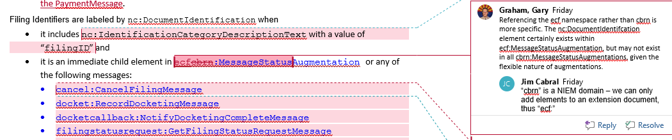

- IdentificationCategoryDescriptionText.gc

Should the newly revised IdentificationCategoryDescriptionText.gc file contain any ‘rows’ within SimpleCodeList?

One might expect “filingID” and “messageID” at a minimum.

- xxx

