Docket Example WD35

The docket example (i.e. docket.xml) included in the examples folder for WD35 appears to have some errors:

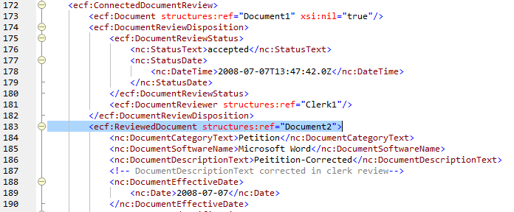

Since line 183 includes structures:ref, and per NIEM rules, it is not allowed to contain other element content (see NIEM NDR Rule 12-2, and ECF5 Appendix F). Since the example appears to be illustrating a ‘verbose copy’ from the filing:FilingMessage, then simply removing structures:ref would correct this problem on this score.

However, since this is intended to reflect clerk review changes to the ‘petition’ document, there is another error (line 173). Since the document that was reviewed and dispositioned is the ‘petition’ document, line 173 should reference ‘Document2” and not “Document1” (Document1 is the appearance document).

Similar issues are also present with the appearance document.

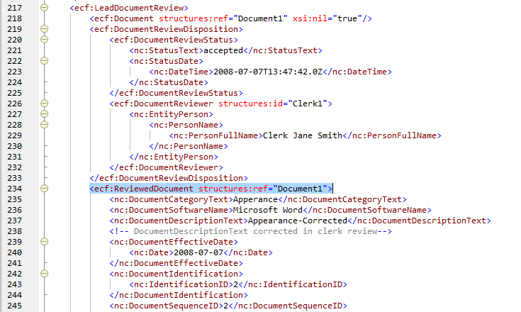

Line 234 is incorrect – It cannot contain structures:ref and include element content.

Line 218 is okay, since it references the appearance document (i.e. “Document1”).

P.S.

This portion of the document was not provided to the TC.

The following highlighted elements should also not be included:

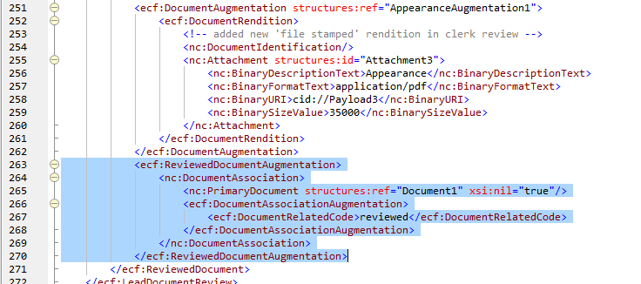

The nc:DocumentAssociation element should be removed from ecf:ReviewedDocumentAugmentation.

