ECF5 Spec Feedback and Considerations – 29

This document provides additional ECF-5 feedback, questions, and commentary. This feedback is based on review of the Electronic Court Filing Version 5.0 Working Draft 39 (WD39), unless otherwise noted. This document does not represent a comprehensive review of WD36 but instead only raises issues uncovered during a limited review time interval. Additional review of WD39, or other future work draft(s), is anticipated as additional time permits.

- Typos

Section 6.1.3. The newly included statement regarding multiple filing:FilingMessages within GetFeesCalculation is inadvertently numbered 6.1.4, as shown below:

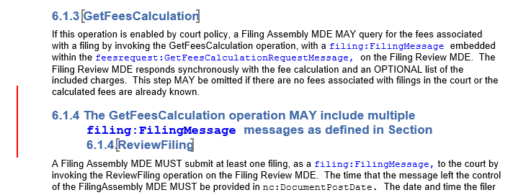

- Sample Messages

Numerous example messages have been modified. The modified examples are contained in the companion zip file (i.e. RevisedExamples.zip). A ‘Modification’ comment section has been added to each revised example detailing the changes made. Most examples were only modified to conform to the specification requirements regarding message identifiers (e.g. sections 6.2.5). Some message examples include other additional modifications.

A comprehensive review was not conducted for the example messages revised – there may be other issues with these messages that require attention.

The example messages revised are:

Allocate.xml
Appellate.xml
AttyDiscipline-RvFR.xml
Cancel.xml
Caselistrequest.xml
Caselistresponse.xml
Citation.xml
Civil-ReviewFilingRequest-01.xml
Criminal.xml
Datecallback.xml
Docket.xml
Docketcallback-cancelled.xml
Documentrequest.xml
Documentresponse.xml
Domestic.xml
Feesrequest.xml
Feesresponse.xml
Filinglistrequest.xml
Filinglistresponse.xml
Juvenile.xml
Messagestatus.xml
New-civil-filing.xml
Policyrequest.xml
Policyresponse.xml
Requestdate.xml
Requestdateresponse.xml
Reservedate.xml
Reviewfilingcallback.xml
Schedulerequest.xml
Scheduleresponse.xml
Serveprocess.xml
Serviceinformationrequest.xml
Serviceinformationresponse.xml
Stampinformation.xml
Stampinformationcallback.xml

