Proposal for Transaction Coordinator Migration for the OASIS Business Transactions Protocol

Geoff Brown ( Geoffrey.Brown@Oracle.com )

9th May 2002

Copyright © Oracle Corporation 2002. All Rights Reserved

ABSTRACT

This proposal seeks to address issue 89 ; Transaction control, interoperability and migration to and from propriety transactional systems.

This proposal supplements an earlier JSR ( specific to J2EE ). It should be noted that this proposal address propriety technology and seeks to lay such technology open via a simplified tight integration with the BTP.

It is the considered opinion of the author that proposed simple “client-server” bindings are not effective in addressing the major problems that the professional industry faces with transaction coordinator control, interoperability and migration between and Open Systems technology and propriety vendor technology.

This text is the second and final submission from Oracle Corporation to be included in the OASIS Business Transaction Protocol standard version 1.0

In common with the spirit of Open Systems, this technology is submitted on a non-fee basis. To the best of the author’s knowledge, the technology described herein violates no-known patentable technology and this the technology described, explict and implied is unique.

E & E accepted.

FORMAL TEXT SUBMISSION

Transaction Coordinator Interoperability and Migration

Overview

It is assumed that Transaction Coordinator Interoperability and migration is conducted on a secure transport.

The BTP specification recognizes that resource participation in complex transactional supply chains is subject to finite scalability limitations, commonly this dynamic manifests itself via state management and resource conflicts. Nowhere is this more evident when multiple heterogenous transactional coordinators participate within a virtual transaction domain that passes across multiple network transports.

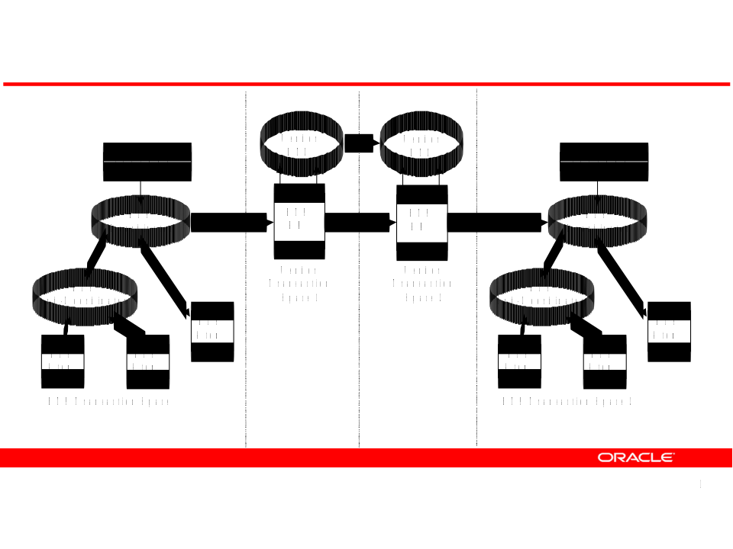

As shown in the above diagram, in this scenario we have four distinct transaction spaces, (i) BTP traditional transaction space 1 (ii) Proprietary transaction space 1 (iii) Proprietary transaction space 2 (iv) BTP traditional transaction space 2. This scenario is representative of a modern internet based distributed supply-chain application suite which has been partitioned into four unique domains.

A key difference of this example is the introduction of a BTP Resource Manager that provides interoperability with native Transactions systems and supports the ability to migrate transaction state from propriety or BTP transaction coordinators on demand.

This powerful aspect of the BTP standard facilitates greater resource control and allows transactional control to be migrated across a transactional domain, this ability is especially valued when traversing mobile wireless infrastructure. Technically this is considered to be a “Peer-to-Peer” approach rather than a traditional “Client-Server” XA approach.

Transaction Coordination Dynamics

The following section provides a detailed description of the Transaction Coordinator Migration process.

It is important to note that transaction migration is supported bi-directionally between the BTP and native transaction space.
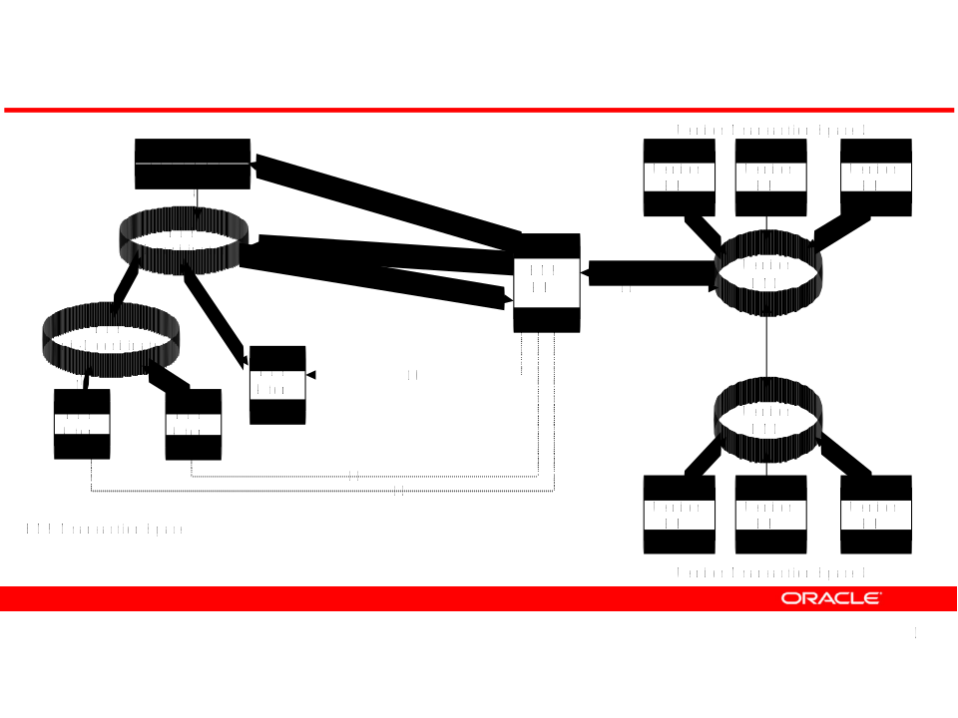

Within the BTP specification, a FACTORY process instantiates the creation of a BTP Coordinator, which in turn has direct visibility of ATOMs ( participant ) and related sub-coordinators; these can also be considered COHESIONS. The Master Coordinator effectively tracks and orchestrates all participants.

Concurrently, within a propriety transactional infrastructure, the native Distributed Transaction Coordinator ( DTC ) manages all local participants ( Vendor RMs ).

It is important to note that the BTP FACTORY has visibility of the BTP RM specific to the vendors transaction space #.

As per the aforementioned graphic (all flows are bi-directional) :

(1) Vendor transaction space 1 requests the migration of the BTP transaction space into the Vendor transaction space 1.

(2) The request is made to the BTP coordinator and (3) the BTP FACTORY via the MIGRATE BTP event.

(4) The BTP Coordinator informs the BTP FACTORY of the request with ACKNOWLEDGEMENT. This also contains the reference of BTP RM that the transactional control and state is to be migrated to.

(5) The BTP Coordinator informs the sub-coordinator and (6) BTP Atom (7) BTP Atom (8) BTP Atom of the MIGRATE event where inturn the participants pass the current state to the origin co-ordinator.

(9) The BTP co-ordinator renders the current state in XML via the TRANSACTIONAL MIGRATION XML definition. The BTP RM updates internal state maps.

(10), (11), (12) BTP ATOMS ( COHESIONS ) are then notified by the BTP RM and (13) these participants join the virtual transaction space of the Vendor RM.

Transaction Migration XML - Node

Initially defined by Oracle Corporation and Choreology :

<btpst:node-information>

<btpst:role>composer|coordinator|sub-composer|sub-coordinator|participant</btpst:role>

<btpst:own-information>
<btpst:own-identifier>...URI...</btpst:own-identifier>
<btpst:own-address> +
<btp:binding-name>...carrier binding URI...</btp:binding-name>
<btp:binding-address>...carrier specific address...</btp:binding-address>
<btp:additional-information>...optional additional addressing information...</btp:additional-information> ?
</btpst:own-address>
</btpst:own-information>

<btpst:information-as-inferior> ?
<btpst:I_state>... statename from inferior state table ...</btpst:I_state>
<btpst:superiors-identifier>...URI...</btpst:superiors-identifier>
<btpst:superiors-address> +
<btp:binding-name>...carrier binding URI...</btp:binding-name>
<btp:binding-address>...carrier specific address...</btp:binding-address>
<btp:additional-information>...optional additional addressing information...</btp:additional-information> ?
</btpst:superiors-address>
<btp:qualifiers> ...qualifiers... </btp:qualifiers> ?
</btpst:information-as-inferior>

<btpst:information-as-superior> +
<btpst:S_state>... statename from superior state table ...</btpst:S_state>
<btpst:inferiors-identifier>...URI...</btpst:inferiors-identifier>
<btpst:inferiors-address> +
<btp:binding-name>...carrier binding URI...</btp:binding-name>
<btp:binding-address>...carrier specific address...</btp:binding-address>
<btp:additional-information>...optional additional addressing information...</btp:additional-information> ?
</btpst:inferiors-address>
<btp:qualifiers> ...qualifiers... </btp:qualifiers> ?
</btpst:information-as-superior>

<btpst:switch-p1> .. BTP major domain .. </btpst:switch-p1>
<btpst:transport> .. BTP transport .. </btpst:transport>
<btpst:XMLContext> .. nested XML format type within other .. </btpst:XMLContect>
<btpst:other-information> Optional additional information – implementation and system owner dependent. Text string that may be structured.
</btpst:other-information> ?

</btpst:node-information>

Transaction Migration XML - Schema

<?xml version="1.0"?>
<schema
xmlns="http://www.w3.org/2001/XMLSchema"
targetNamespace="urn:oasis:names:tc:BTP:1.0:node_state_information"
xmlns:btst="urn:oasis:names:tc:BTP:1.0:node_state_information"
xmlns:btpq="urn:oasis:names:tc:BTP:1.0:qualifiers"
xmlns:btp="urn:oasis:names:tc:BTP:1.0:core"
elementFormDefault="qualified" version="0.1">

<import namespace="urn:oasis:names:tc:BTP:1.0:qualifiers"/>
<import namespace="urn:oasis:names:tc:BTP:1.0:core"/>

<element name="node-information">
<complexType>
<sequence>

<element name="role">
<simpleType>
<restriction base="string">
<enumeration value="composer"/>
<enumeration value="coordinator"/>
<enumeration value="sub-Composer"/>
<enumeration value="sub-Coordinator"/>
<enumeration value="participant"/>
</restriction>
</simpleType>
</element>

<element name="own-information">
<complexType>
<sequence>
<element name="own-identifier" type="btp:identifier"/>
<element name="own-address" type="btp:address" minOccurs="1" maxOccurs="unbounded"/>
</sequence>
</complexType>
</element>

<element name="information-as-inferior" minOccurs="0">
<complexType>
<sequence>
<element name="I_state">
<simpleType>
<restriction base="string">
<pattern value="[a-z][0-9]"/>
</restriction>
</simpleType>
</element>
<element name="superiors-identifier" type="btp:identifier"/>
<element name="superiors-address" type="btp:address" minOccurs="1" maxOccurs="unbounded"/>
<element ref="btp:qualifiers" minOccurs="0"/>
</sequence>
</complexType>
</element>

<element name="information-as-superior" minOccurs="0" maxOccurs="unbounded">
<complexType>
<sequence>
<element name="S_state">
<simpleType>
<restriction base="string">
<pattern value="[A-Z][0-9]"/>
</restriction>
</simpleType>
</element>
<element name="inferiors-identifier" type="btp:identifier"/>
<element name="inferiors-address" type="btp:address" minOccurs="1" maxOccurs="unbounded"/>
<element ref="btp:qualifiers" minOccurs="0"/>
</sequence>
</complexType>
</element>

<element name="other-information" type="string" minOccurs="0"/>

</sequence>
</complexType>
</element>
</schema>

