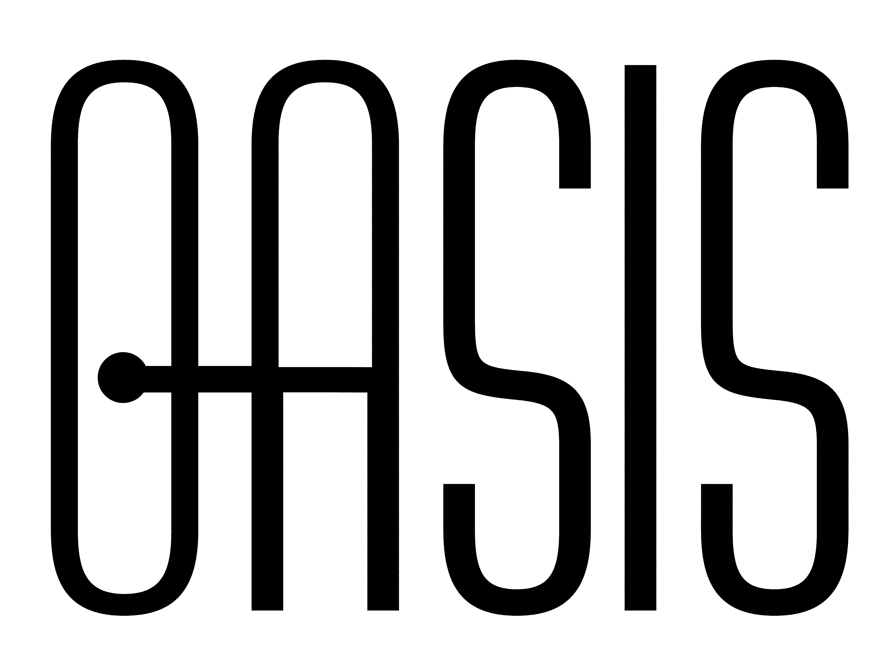
UBL Code List Rules: A White Paper
White Paper 01, 25 September 2002
Document identifier:
wp-ubl-codelist-01
Location:
http://www.oasis-open.org/committees/ubl/ndrsc/archive/
Editor:
Eve Maler, Sun Microsystems <eve.maler@sun.com>
Abstract:
This white paper describes the motivation for, potential benefits from, and mechanism used in the UBL rules for reusable code lists.
Status:
This is a draft document. It may change at any time.
This document was developed by the OASIS UBL Naming and Design Rules subcommittee. Your comments are invited. Members of this subcommittee should send comments on this specification to the ubl-ndrsc@lists.oasis-open.org list. Others should subscribe to and send comments to the ubl-comment@lists.oasis-open.org list. To subscribe, send an email message to ubl-comment-request@lists.oasis-open.org with the word "subscribe" as the body of the message.
Table of Contents
1 Introduction 3
2 The Proposed Solution 5
3 Further Reading 6
Appendix A. Notices 7

Introduction
What is a code? The ebXML Core Components specification defines it as:
A character string (letters, figures or symbols) that for brevity and/or language independence may be used to represent or replace a definitive value or text of an attribute. Codes usually are maintained in code lists per attribute type (e.g. colour).
Business documents use codes frequently to convey information. For example, product orders might supply a color code to indicate clearly which color of each product is desired. Addresses often have a country code to say unambiguously what country the address is located in.

In addition to the benefits of brevity and language independence, if a code comes from a well-identified and well-defined list it is also unambiguous in its meaning. In fact, several organizations worldwide specialize in producing and maintaining code lists to help code users achieve this goal. For example, the International Organization for Standardization (ISO) produces a list of country codes as ISO standard 3166, and the United Nations Economic Commission for Europe (UN/ECE) publishes this same code list in order to facilitate electronic trade.
With the increasing popularity of XML as a means of conveying business documents, we need to ask: How can codes best be handled in XML form? XML and its related technologies, such as schemas, allows for new kinds of interoperable sharing, validating, and processing of codes.
The Universal Business Language (UBL) effort taking place at OASIS asked this very question. UBL is a library of reusable and extensible XML business information formats (such as purchase orders and all the pieces of information inside them), and it intends to be a heavy consumer of code lists. The trick is that UBL does not want to become a heavy producer of code lists; it is costly and time-consuming to define code lists, and it would be better for reasons of both efficiency and interoperability to reuse the excellent lists that are already available.

But since UBL is an XML-based library, and most code lists are not available in XML form, we need to encourage code list producers to offer an XML-friendly form for those lists so that we can reuse them and not have to duplicate any work that went into them. The work in the UBL committee has resulted in a specific form of encouragement: a technical specification called the “UBL Code List Rules”, along with an offer to help code list producers apply these rules.
Luckily, UBL is not the only XML language that has an interest in using XML-based code lists; there are many other potential “customers” as well, which we hope will make conforming to the rules more attractive. To the degree that code list producers conform to these rules when creating electronic representations of their code lists, and to the degree that these representations are picked up and used in XML languages, we foresee the following potential benefits:
- Less duplication of work in the development of XML languages and the applications that support them
- Wider application platform support for well-known code lists, which could allow (for example) easy building of web-based GUI forms that have support for code picklists
- “Earlier and oftener” validation of code correctness in XML documents using schema-based validation technology
- The standardization of more, and more-useful, code lists, with some possibly being subsets or extensions of existing ones
- Easier translation of XML documents into alternative XML and non-XML representations with respect to code usage
In summary, if we are successful in promoting adoption and use of the UBL Code List Rules, we believe we will enable a global code list marketplace, which will benefit both code list producers and code list consumers and improving the state of electronic trade as a whole.
The next section briefly describes the mechanisms by which the UBL Code List Rules make these outcomes possible.

The Proposed Solution
In order to conform to the UBL Code List Rules (“the Rules”), a code list producer first needs to figure out the essential pieces of identifying information that make their code list unique from all others. These pieces of information must include:
- An “XML namespace name” representing the XML definition of the code list
- A unique identifier for the agency that owns the list (that is, the code list producer)
- A unique identifier for the code list (this can be the same as the XML namespace name)
- An identifier indicating the list’s version (because code lists undergo revision from time to time)
Then the producer needs to write and maintain an XML schema, using the W3C XML Schema definition language (XSD) and following the prescriptions laid out in the Rules, that represents the definition of the code list for purposes of XML reuse. This schema need not be the only definition of the code list – for example, the list might also have a definition in prose, definitions in other XML or non-XML schema languages, and so on – but for XML-based reuse, a schema needs to be made available that conforms to the Rules.
The code list producer is able to place constraints on valid codes that are as “tight” or “loose” as desired, depending on the nature of each code list and its typical uses. However, the prescriptions in the Rules do describe a precise interface between a code list producer’s schema and a code list consumer’s schema.

The way this works is as follows: The producer’s schema (such as a schema for ISO 3166 country codes) defines an XSD “complex datatype” that the consumer’s schema (such as the UBL Library) can associate with one of its own XML elements, where this element is designed to hold codes exclusively from that list. This allows the UBL element to be governed by the constraints and identification fields provided by (in this example) the ISO 3166 country code schema, while being unambiguously associated with that code list alone. This way, if in a UBL-conforming document this element appears and contains the code “DE”, there is never any doubt about what the code means.
In fact, the Rules allow for several different ways for the two schemas to interface, and thus gives some flexibility to both parties in deciding what to offer and accept for reuse. However, all of the choices have the same essential result: a reusable, unique code list definition and an XML language that successfully takes advantage of it.

Further Reading
- OASIS UBL Code List Rules, http://www.oasis-open.org/committees/ubl/ndrsc/archive/wd-ublndrsc-codelist-nn
This is the normative specification of the Rules. It is in draft form so far.
- OASIS UBL code list module template, http://www.oasis-open.org/committees/ubl/ndrsc/archive/CodeListModuleTemplate.xsd
This is a sample XSD schema module that can be used as a template by code list producers. It is also in draft form.
- UN/ECE XSD code list module for ISO 3166-1, http://www.unece.org/etrades/unedocs/repository/codelist.htm
This organization has been the first to experiment with conforming to the UBL Code List Rules.
- UN/CEFACT Draft Core Components Specification, Part 1, 8 February 2002, Version 1.8
This document provided the definition of “code” reproduced in this white paper, and also defines many other important concepts related to standardized business information.
- OASIS UBL Naming and Design Rules subcommittee, portal http://www.oasis-open.org/committees/ubl/ndrsc/, email archive http://lists.oasis-open.org/archives/ubl-ndrsc/
This is the subgroup within the OASIS UBL Technical Committee that produced the Code List Rules and this white paper.
- Notices
OASIS takes no position regarding the validity or scope of any intellectual property or other rights that might be claimed to pertain to the implementation or use of the technology described in this document or the extent to which any license under such rights might or might not be available; neither does it represent that it has made any effort to identify any such rights. Information on OASIS's procedures with respect to rights in OASIS specifications can be found at the OASIS website. Copies of claims of rights made available for publication and any assurances of licenses to be made available, or the result of an attempt made to obtain a general license or permission for the use of such proprietary rights by implementors or users of this specification, can be obtained from the OASIS Executive Director.
OASIS invites any interested party to bring to its attention any copyrights, patents or patent applications, or other proprietary rights which may cover technology that may be required to implement this specification. Please address the information to the OASIS Executive Director.
Copyright © OASIS Open 2002. All Rights Reserved.
This document and translations of it may be copied and furnished to others, and derivative works that comment on or otherwise explain it or assist in its implementation may be prepared, copied, published and distributed, in whole or in part, without restriction of any kind, provided that the above copyright notice and this paragraph are included on all such copies and derivative works. However, this document itself does not be modified in any way, such as by removing the copyright notice or references to OASIS, except as needed for the purpose of developing OASIS specifications, in which case the procedures for copyrights defined in the OASIS Intellectual Property Rights document must be followed, or as required to translate it into languages other than English.
The limited permissions granted above are perpetual and will not be revoked by OASIS or its successors or assigns.
This document and the information contained herein is provided on an “AS IS” basis and OASIS DISCLAIMS ALL WARRANTIES, EXPRESS OR IMPLIED, INCLUDING BUT NOT LIMITED TO ANY WARRANTY THAT THE USE OF THE INFORMATION HEREIN WILL NOT INFRINGE ANY RIGHTS OR ANY IMPLIED WARRANTIES OF MERCHANTABILITY OR FITNESS FOR A PARTICULAR PURPOSE.

